date of adoption

Replace seal on the left with your agency seal.

chan

Emergency Operations Plan Jurisdictional Model EMERGENCY OPERATIONS PLAN

Add your agency seal.

Your Agency
Agency Address

EOP MODEL AND INSTRUCTIONS
The purpose of this model is to provide instructions, guidance, and sample text for the development of city/jurisdiction emergency operations plans in accordance with Comprehensive Preparedness Guide 101: Developing and Maintaining Emergency Operations Plans (CPG-101).
Use of this model is voluntary, and users are encouraged to tailor the plan development to meet their jurisdiction’s needs and requirements. The model is available to all partners within the Santa Clara County Operational Area (and beyond) in a flexible format so that organizations may choose to use all portions or only certain sections of the model to build or improve their emergency operations plan.
An electronic version of this document, in Microsoft Word and portable document format (PDF) is available on the County website under the ‘For Partners’ section at:
https://www.sccgov.org/sites/oes/partners/pages/home.aspx
Please Note: As you review the document, portions highlighted in red should be edited accordingly. Additionally, be sure to edit headers/footers, add localized logos/images that are unique to your jurisdiction where appropriate, and reference your local ordinances and/or statutory authorities.

Acknowledgements
We would like to acknowledge contributions from the following cities and towns; special districts; county departments and agencies; state agencies; federal agencies; and other planning partners:
Category of Agency/Jurisdiction
Example agency or jurisdiction #1
Example agency or jurisdiction #2
Etc…

Executive Summary
The (insert your jurisdiction here) Emergency Operations Plan (EOP) is an all-hazards document describing the city/jurisdiction incident management organization, compliance with relevant legal statutes, other relevant guidelines, whole community engagement, continuity of government focus, and critical components of the incident management structure. The incident management system is a component based system designed to be scaled up and components activated as necessary to reflect the incident/event’s escalation from routine incident(s) to emergency, disaster, or catastrophe affecting the city/jurisdiction. This EOP is not intended to address specific emergency responses, scenarios, hazards, or threats. Functional and hazard specific annexes to this EOP will outline specific response activities for response organizations.
This Emergency Operations Plan (EOP) accomplishes the following:

Establishes a jurisdictional incident management organization which will coordinate and support on-scene responses including maintenance of situational awareness, facilitation of effective communication between operations centers at various levels of government, maintain continuity of government, and interaction with public information sources.

Establishes the overall operational concepts associated with the management of incidents, emergencies, crises, disasters, and catastrophes at the city/jurisdiction and operational area levels.

Provides a flexible platform for planning and response to all hazards, incidents, events, and emergencies believed to be important to the city/jurisdiction. It is applicable to a wide variety of anticipated incident events including earthquake, wildland fires, floods, and public health issues.
This EOP continues the city’s/jurisdiction’s compliance with the Standardized Emergency Management System (SEMS), the National Incident Management System (NIMS), the Incident Command System (ICS), the National Response Framework (NRF), and the National Preparedness Guidelines to include Comprehensive Preparedness Guide 101: Developing and Maintaining Emergency Operations Plans (CPG-101). It facilitates multi-agency and multi-jurisdictional coordination during emergency operations, public information functions, and resource management.
This EOP serves as the legal and conceptual framework for incident management to be utilized by the city/jurisdiction and its various departments within municipal government. There are a number of separately published annexes that support this EOP. These supporting annexes further describe the operational or functional response to particular threats and hazards and the basic considerations, actions, and responsibilities of specific emergency response and management disciplines or functions.
Promulgation
The preservation of life, property, the environment, and the economy is an inherent responsibility of local, state, and federal government. While no plan can completely prevent death and destruction, reasonable plans carried out by knowledgeable and well-trained personnel can and will minimize losses.
The (insert your city/jurisdiction here) has prepared this Standardized Emergency Management System (SEMS) and National Incident Management System (NIMS) compliant (insert your city/jurisdiction here) Emergency Operations Plan (EOP) to ensure the most effective and efficient allocation of resources for the maximum benefit and protection of the civilian population during times of emergency.
This EOP establishes the emergency organization, assigns tasks, specifies policies and general procedures, and provides for coordination of planning efforts for respective staff.
This EOP will be reviewed and exercised periodically and revised as necessary to satisfy changing conditions and needs.
The (Insert statutory authority of your city/jurisdiction/unincorporated area) gives their full support to this Emergency Operations Plan and urge all officials, employees, and residents—individually and collectively—to do their share in the whole community emergency effort of the (insert your city/jurisdiction here). This EOP became effective on January XX, 2018 when approved by the (Insert statutory authority of your city/jurisdiction/unincorporated area)

_____________________________________________ ____________________
Appropriate signatory Date

_____________________________________________ ____________________
Appropriate signatory Date

_____________________________________________ ____________________
Appropriate signatory Date

(Insert statutory authority of your city/jurisdiction/unincorporated area) Council Adoption Approval
Insert City Council (or other appropriate approval authority) approval once document is approved

Annual Review
Your agency, with input from essential stakeholders across the city/jurisdiction, is responsible for maintaining, reviewing, and updating this Emergency Operations Plan (EOP). They will—at a minimum—review this EOP every (set time) in accordance with your agency plan maintenance policy. It is essential that OES make revisions and updates in collaboration with participating local jurisdictions and other planning partners identified in the EOP to ensure accuracy and validity. If the EOP requires an immediate change due to lessons learned from trainings, exercises, or actual incidents, the city/jurisdiction will identify a course of action for the review, update, and implementation of the necessary changes. All changes will be noted in the table below.
VERSION | DATE | NAME/ORGANIZATION | CHANGE DESCRIPTION
Record of Distribution
DATE | NAME / TITLE | ORGANIZATION | # OF COPIES

insert your jurisdiction here
EMERGENCY OPERATIONS PLAN

Acknowledgements i
Executive Summary iii
Promulgation iv
(Insert statutory authority) Adoption Approval v
Annual Review vi
Record of Distribution vii
Purpose, Scope, Situation Overview, and Assumptions 1
Purpose 2
Scope 2
Situation Overview 3
Planning assumptions 22
Concept of Operations 25
National Response Framework (NRF) 26
Standard Emergency Management System (SEMS) 26
National Incident Management System (NIMS) 27
Incident Command System (ICS) 27
Integrating Federal, State, and local Systems 27
Phases of Emergency Management 28
Organization and Assignment of Responsibilities 31
Field Response 32
Local Government 32
Operational Area (OA) 33
Region 38
State 39
Additional Support and Planning Organizations 39
Direction, Control, and Coordination 43
Direction and Control Interface 44
Operational Area Coordination and Communication 44
Multi-Agency Coordination Groups 47
Information Collection, Analysis, and Dissemination 49
Information Collection and Management Tool 50
Crisis Communications and Public Information 53
Joint Information System (JIS) 54
Joint Information Center (JIC) 54
Communication Systems 55
Public Awareness and Education 56
Administration, Finance, and Logistics 59
Finance Considerations 60
Mutual Aid 62
Resource management 65
Plan Development and Maintenance 69
Plan Development 70
Plan Maintenance 70
Plan Concurrence 70
Plan Training and Exercise 71
Authorities and References 75
Federal 76
State 76
Local 77
Glossary 79
Appendix A – County of Santa Clara Emergency Operations Plan Annexes A-1
Appendix B – Local / State / Federal Crosswalk A-9
Appendix C – EOP Annex Planning Process Guide A-13

Purpose, Scope, Situation Overview, and Assumptions

Purpose, Scope, Situation Overview and Assumptions

Purpose
This (insert your city/jurisdiction here) Emergency Operations Plan (EOP) provides a comprehensive, single-source of guidance and procedure for the city/jurisdiction to prepare for, respond to, and manage significant or catastrophic natural or man-made threats, crises, incidents, or events that produce situations requiring a coordinated response. This EOP is intended to conform to the requirements of the National Incident Management System (NIMS), Standardized Emergency Management System (SEMS), Incident Command System (ICS), and the California State Emergency Plan for managing response to multi-agency and multi-jurisdictional incidents, and to be consistent with federal and state emergency plans and guidance documents. Best practices and lessons-learned have also been integrated into this plan where possible; these were identified in the review of after-action reports from recent national large-scale disasters, incidents, and events (to include Stafford Act, non-Stafford Act, terrorist non-Stafford act, and off-shore non-Stafford act incidents and events).
This EOP is intended as a concept of collaboration and consistency amongst various internal departments and their specific incident management plans, procedures, functions, and capabilities. As such, the EOP is flexible enough to use in all incident types, and will facilitate short-term recovery activities.
In the event of an emergency or disaster the city/jurisdiction primary responsibility is to maximize the safety of the public, to minimize property and environmental damage, and ensure the continuity of government. To aid in accomplishing this goal, the city/jurisdiction has adopted the principles of SEMS, NIMS, and ICS so that responses to such conditions are done in the most organized, efficient, and effective manner possible. All jurisdictions within the OA operate under SEMS, NIMS, and ICS, which are used to manage and control the response operations.

Scope
This EOP provides guidance on response to the city/jurisdiction most likely and demanding emergency conditions. It does not supersede the well-established operational policies and procedures for coping with and responding to day-to-day emergencies involving law enforcement, the fire service, medical aid, transportation services, flood control, or other discipline-specific emergency response systems. It is intended as a supplement and compliment to such systems. This EOP does however place emphasis on those unusual and unique emergency conditions that will require extraordinary response beyond the ability of any one or common set of organizations to respond. Neither does this EOP include detailed response level operating instructions or procedures. Each organization identified in this EOP is responsible for, and expected to develop, implement, and test policies, instructions, and standard operating procedures (SOPs) or checklists that reflect the tactical, operational, strategic, and executive mission spaces and incident management concepts contained in this EOP. Coordinated response and support roles must be defined by these organizations to facilitate the ability to respond to and manage any given incident.
This document is not intended to be an overview of the city/jurisdiction Emergency Operations Center functions, procedures, section responsibilities, or positions specific standard operating procedures. These issues are covered more specifically in the Emergency Management Annex to this EOP, and in the Standardized Emergency Management System (SEMS) position specific checklists which are maintained in position specific binders in the EOC (specify location based on your city/jurisdiction).

Comprehensive Emergency Operations Plan Components
The below graphic describes the process and purpose of this document and how it can be utilized by a jurisdiction and objectives in creating it. Why the document has been created, the needs it fills and their importance to the emergency management framework.

Situation Overview (Update your City/Jurisdiction Overview below)
Example Given: General Background: The County of Santa Clara, also referred to as “Silicon Valley,” is located at the southern end of the San Francisco Bay and encompasses 1,312 square miles. The Santa Clara Valley runs the entire length of the county from north to south, ringed by the rolling hills of the Diablo Range on the east, and the Santa Cruz Mountains on the west. The county is bordered by Stanislaus and Merced counties to the east, San Mateo and Alameda counties to the north, Santa Cruz County to the west and San Benito County to the south. Salt marshes and wetlands lie in the northwestern part of the county, adjacent to the waters of San Francisco Bay.
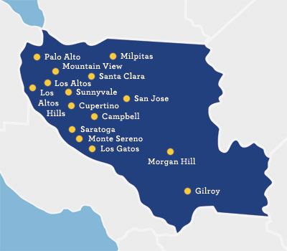
Census/geographic related information: The county’s diverse population of over 1.89 million (US Census Bureau, 2014) is one of the largest populations in the state and is the largest of the ten Bay Area counties. Its population constitutes about one fourth of the Bay Area’s total population. The county has a culture rich in its history and ethnic diversity with over 100 languages and dialects spoken.
Santa Clara County encompasses the 15 cities and towns of Campbell, Cupertino, Gilroy, Los Altos, Los Altos Hills, Los Gatos, Milpitas, Monte Sereno, Morgan Hill, Mountain View, Palo Alto, San José, Santa Clara, Saratoga, and Sunnyvale. Ranging from Palo Alto in the north, to Gilroy in the south. San José is the largest city in the county, with a population of over 1,015,000 (US Census Bureau, 2014). A significant portion of the county’s land area is unincorporated ranch and farmland. Nearly 92% of the population lives in cities.
Sports/recreation/colleges/universities related info: In sports and recreation, San José is home to teams for soccer, minor league baseball, and professional ice hockey. Local sports teams include the San Francisco 49ers, the San Jose Sharks, San Jose Earthquakes, San Jose Saber Cats, and the San Jose Giants. Numerous public and private golf courses are located throughout the county. In addition to these recreational outlets, the County operates 28 parks covering more than 50,000 acres. The county is home to three major universities—Stanford University, Santa Clara University, and San Jose State University. Local museums and art galleries include The Tech Museum of Innovation, the Rosicrucian Museum, the Children's Discovery Museum, the San Jose Museum of Art, and the Triton Museum of Art. Local theme parks and venues for children and adults include California's Great America, Gilroy Gardens, Raging Waters, and the Santa Clara County Fairgrounds. Special events include the San Jose Jazz Festival, Gilroy Garlic Festival, and the Morgan Hill Mushroom Mardi-Gras.
Commerce related info: The local industry is dominated by the technology sector. Computer software and hardware manufacturing, wholesale, and services in particular are some of the largest industry segments in terms of both annual revenues and employees.
Transportation related info: The county has three main interstate highways; 280, 680, and 880, U.S. Route 101, and the following State Routes; 9, 17, 82, 85, 87, 130, and 237. Mass transit in the county includes: Santa Clara Valley Transportation Authority (VTA) with bus and light rail service, Caltrain, Amtrak, and ACE Train. Airports include: San Jose International Airport, Moffett Federal Airfield, two county airports: Reid Hillview, and South County, and Palo Alto Airport.

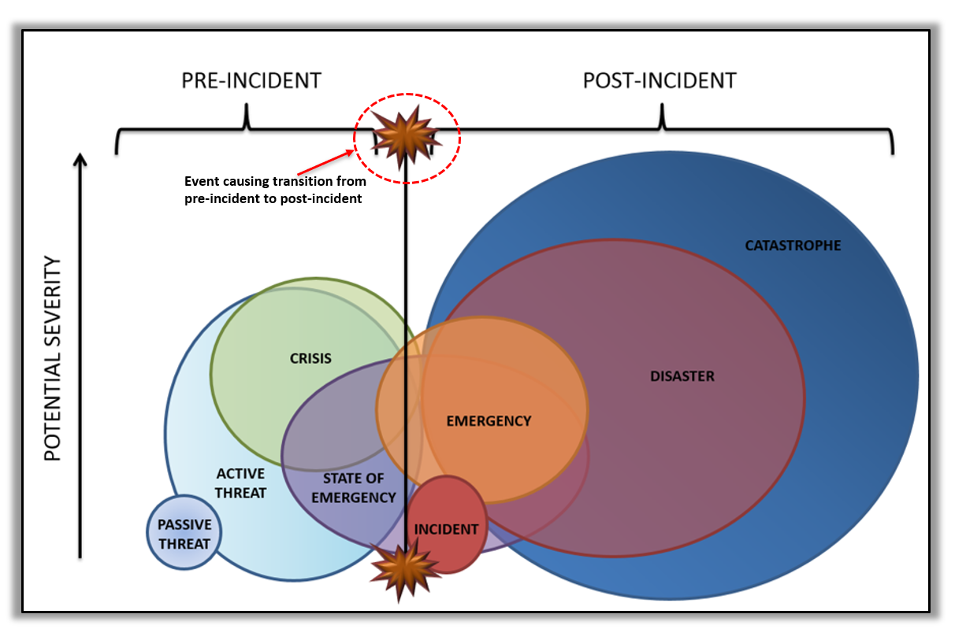
Event Types Defined
Catastrophe A series of cascading human-caused/influenced events or incidents with or without a human caused genesis, the adverse effects/consequences of which are potentially, seemingly, or definitively irreversible.
Disaster Any natural event or emergency (hurricane, tornado, storm, high water, wind-driven water, tidal wave, tsunami, earthquake, volcanic eruption, landslide, mudslide, snowstorm, drought, etc.), or regardless of cause, any fire, flood, or explosion which the President determines to be of such severity as to warrant major federal disaster assistance.
Emergency Incident(s) or crisis(es) (air pollution, fire, flood, storm, epidemic, riot, drought, sudden/severe energy shortage, plant or animal infestation or disease, Governor’s warning of volcanic predictions, and earthquakes, etc.) posing threat to safety of persons, property, or the environment that exceeds an organization’s resources/capability.
Incident The physical manifestation of crisis, event, or occurrence that has adversely affected life, property, or the environment requiring the response of at least one individual.
State of Emergency An eminent impending incident(s) or crisis(es) posing threat to safety of persons, property, or the environment that is/are likely to exceed resources/capability of the proclaiming political jurisdiction, or, the existence of an active incident which threatens a population and the adequacy of local resources is unknown.
Crisis Phenomenon, event, active threat, or trend, with or without specific location, posing seemingly inevitable harm to life, property, environment, organizational performance, reputation, or way of life reasonably or ethically necessitating deliberate urgent intervention. (A crisis may be local, national, or global).
Active Threat Known communicated, demonstrated, or inferred timely intent and capability to harm life, property, environment, organizational performance, or way of life with specified or unspecified target.
Passive Threat Existing communicated, demonstrated, or inferred intent and potential capability to harm life, property, environment, organizational performance, or way of life.

Hazard Analysis Overview (This information below is the OA hazard analysis overview. your city/jurisdiction needs to Complete a similar overview. However, much of it will overlap.)
This section of the EOP consists of a series of threat summaries based upon an OA hazard analysis. This hazard analysis was conducted by the Office of Emergency Services (OES) and provides a description of the local area, risk factors, and the anticipated nature of situations, which could threaten or occur in the county. If future annex or hazard mitigation plan development result in more current or robust hazard or threat analysis data, future EOP revisions will incorporate that data into this section. The following identified threats are discussed:

Major Earthquake

Wildland/Urban Interface Fire

Flood

Landslide

Drought/Land Subsidence

Climate Change

Thunderstorms and Lightning

Heat

Public Health Emergency

Technological and Resource Emergency

Hazardous Material Incident

Terrorism, Complex and Coordinated Attack, & Civil Unrest
It is important to note that these hazards are not mutually exclusive hazards. One or more of these events may occur simultaneously. Specific actions to be accomplished in response to these hazards are contained in the functional and hazard specific annexes that are separate from this EOP as well as department specific SOPs.
Annually, the Bay Area Urban Area Security Initiative (UASI) coordinates a regional effort to identify, catalog, and prioritize threats and hazards across the Bay Area. This effort culminates in an annually updated report called the Threat and Hazard Identification and Risk Assessment (THIRA). The THIRA helps local public safety agencies prioritize grant funding and preparedness/mitigation endeavors to improve capabilities to address the most serious and highly prioritized risks and gaps. The hazards below (in addition to other risk factors) are addressed within the THIRA.
Major Earthquake The OA is in the vicinity of several known active and potentially active earthquake faults including the San Andreas, Hayward, and Calaveras faults. A 2014 USGS Earthquake Probabilities Working Group updated the 30-year earthquake forecast for California. They concluded that there is a 72 percent probability (or likelihood) of at least one earthquake of magnitude 6.7 or greater striking somewhere in the San Francisco Bay Area region before 2043. A major earthquake of this magnitude occurring in or near the Santa Clara County Operational Area may cause many deaths and casualties, extensive property damage, and other ensuing hazards. The effects could be aggravated by aftershocks and by the secondary effects of fire, hazardous material/chemical accidents, and possible failure of waterways and dams. Such an earthquake would be catastrophic in its effect upon the population and could exceed the response capabilities of the individual cities/towns, the OA, the California Governor’s Office of Emergency Services (Cal OES), and other state agencies. Emergency operations could be seriously hampered by the loss of communications and damage to transportation routes within, and to and from the disaster area, and by the disruption of public utilities such as power and water.
Two major local earthquakes that have impacted the county include:

San Francisco Earthquake (1906), magnitude 7.8, 3000 fatalities reported

Loma Prieta Earthquake (1989), magnitude of 6.9, 63 fatalities
Other significant local earthquakes near or within the county include:

Concord Earthquake (1955), magnitude 5.4, 1 fatality

Daly City Earthquake (1957), magnitude 5.3, 1 fatality

Morgan Hill Earthquake (1984), magnitude 6.2, no fatalities

Alum Rock Earthquake (2007), magnitude 5.6, no fatalities
The most significant earthquake action in terms of potential structural damage and loss of life is ground shaking and fire. Ground shaking is the movement of the earth's surface in response to a seismic event. The magnitude of the earthquake, distance from the epicenter, and characteristics of surface geology determine the intensity of the ground shaking and the resultant damages.
Damage may include destruction of buildings making some uninhabitable due to the phenomenon of liquefaction. Liquefaction is the loss of shear strength of a soil. The shear strength loss results from the increase of water pressure caused by the rearrangement of soil particles induced by shaking or vibration. Liquefaction has been observed in many earthquakes, usually in soft, poorly graded granular materials (i.e., loose sands), with high water tables. Liquefaction usually occurs in the soil during or shortly after a large earthquake.
Every building in the county is exposed to high risk of damage in earthquakes by virtue of being located in a seismically active part of the country. Some of these structures face an elevated risk because they are located in high hazard zones, such as near a fault, on liquefiable soils, or on slopes subject to landslides. Other structures face high risk because their construction quality is inadequate to withstand strong shaking, as they were built decades ago, before modern building codes were enacted.
Major power plants are expected to sustain some damage due to liquefaction and the ground shaking intensity of the earthquake. The potential impact to the county is lessened by the availability of power from other sources outside the affected area and significant reduction in consumer demand is expected as well. The PG&E Metcalf Transmission Substation is located in an area of predicted strong shaking and is expected to sustain major damage.
Another major concern is whether an earthquake disrupts water availability and distribution for needed life support, to treat the sick and injured, and for fire suppression activities. The dams located in the county may be affected during earthquakes and our water distribution systems including the Delta in the Central Valley may be damaged.
Wildland/Urban Interface Fire The combination of highly flammable fuel, long dry summers and steep slopes creates a significant natural hazard of large wildland fires in many areas of the county. A wildland fire is a fire in which the primary fuel is natural vegetation. Wildland fires can consume thousands of acres of vegetation, timber and agricultural lands. Fires ignited in wildland areas can quickly spread, if unabated, to areas where residential or commercial structures are intermingled with wildland vegetation. Fires that start in urbanized areas can grow into wildland fires. Wildland/urban interface fire hazards are especially pronounced in areas of high structure densities adjacent to undeveloped open space areas with dense vegetation. A wildland/urban interface fire can result in death, injury, economic loss, and a large public investment in fire-fighting activities. Fires can rapidly proliferate to the point that local resources are inadequate.
Wildfire behavior is based on three primary factors: weather, topography and fuel. Wildland fire season in the county spans the months after the last spring rains have fallen and until the first fall or winter rains occur. The months of August, September, and October have the greatest potential for wildland fires as vegetation dries out, humidity levels fall, and off shore winds blow.
Each city in the county is responsible for its fire protection either by utilizing its own resources or contracting with the California Department of Forestry and Fire Protection (CAL FIRE), a fire district, or adjacent municipal service. The unincorporated area is the primary responsibility of CAL FIRE, along with some fire protection districts, and volunteer fire companies.
Wildfires can be caused by natural events, such as lightning or high winds. However, most wildland fires are human caused. Campfires, careless smokers, electrical sparks, and arson cause most wildland and wildland/urban interface fires. In Santa Clara County, electrical equipment, such as power lines and transformers have caused numerous fires. An emerging cause for concern is fires started by the use of mowing and power equipment around very dry vegetation.
Ground fire resources are augmented by a CAL FIRE helicopter stationed at the Alma fire station near Lexington Reservoir and air tankers based at Hollister Airport.
Fire agencies in the county have signed a countywide mutual aid agreement to ensure firefighting resources and personnel will be available to combat wildland / urban interface fires. If these resources within the county are not enough to meet the threat, fire resources from throughout California can be summoned under the State’s Master Mutual Aid Agreement administered by the Cal OES. All fire agencies in Santa Clara County have signed the California Master Mutual Aid Agreement and participate in mutual aid operations as required.
Additionally, in 2016 the Santa Clara County Community Wildfire Protection Plan (CWPP) was published. The CWPP is a collaborative approach for reducing wildland fire risks to communities and the environment. The plan includes an analysis of conditions such as fire apparatus access, community evacuation, fuels, topography, and weather. The plan also includes proposed projects developed through workshops. The initial focus is on the built environments that intermingle with the vegetated areas of the mountains and hillsides.
Flood There are approximately 700 miles of creeks and rivers in the county, all of which are susceptible to flooding. Floods are generally classed as either slow-rise or flash floods. Slow-rise floods may be preceded by a warning time lasting hours, days, or possibly weeks. Evacuation and sandbagging for a slow-rise flood may lessen flood-related damage. Conversely, flash floods are the most difficult to prepare for, because the warning will be short, if any is given at all. Flash flood warnings usually require immediate evacuation.
The National Weather Service (NWS) issues flash flood watches and warnings. A flash flood watch is issued when flash flooding is possible within the designated watch area but the occurrence location, and/or timing is still uncertain, indicating all persons should be alert. A flash flood warning indicating all persons should take necessary precautions is issued when a flash flood has been reported, is in progress, is imminent, or highly likely.
No area is immune to flash floods. On small streams, especially near the headwaters of river basins, water levels may rise quickly in heavy rainstorms, and flash floods can begin before the rain stops falling. Flash floods also occur in or near mountainous areas where torrential rains can quickly change a dry watercourse or small brook into raging torrents of water.
All low lying areas are subject to flood conditions. Urban development in flood plain areas are often subject to seasonal inundation. The flood plain is a natural extension of any waterway, although infrequently used. Storm water runoff that exceeds the capabilities of stream and drainage channels, results in the natural flooding of a localized area.
Dam inundation is flooding which occurs as a result of structural failure of a dam. The most common cause of dam failure is overtopping where the water behind the dam flows over the face of the dam and erodes the structure. Structural failure may be caused by seismic activity. Seismic activity that produces inundation generating a seismically induced wave that overtops the dam without also causing dam failure is referred to as a seiche.
The Santa Clara Valley Water District (SCVWD) maintains emergency action plans for the following water system facilities within the county:

Almaden Dam

Anderson Dam

Calero Dam

Chesbro Dam

Coyote Dam

Coyote Percolation Dam

Guadalupe Dam

Lenihan Dam

Rinconada Water Treatment Plant and Dam

Stevens Creek Dam

Uvas Dam

Vasona Dam
Automated Local Evaluation in Real Time (ALERT) is a cooperative program initiated by the NWS's California-Nevada River Forecast Center in the 1970s. SCVWD began installation of its ALERT system in 1983, and its system currently includes 42 rain gauges, 68 stream flow gauges, and 10 reservoir gauges.
In the ALERT program, a local agency installs, maintains, and monitors event-reporting field sensors that report current hydrologic conditions, in real time, through radio telemetry. Event-reporting refers to the ability of sensors to transmit their status as hydrologic conditions change; i.e. rainfall occurs or streams and reservoirs rise and/or fall. Such sensor status data transmissions are received by a base station, which decodes the radio signal's site of origin, and data value. These values are logged in a computer database for report generation, analysis, and archiving purposes. Through a system of radio repeater sites, as well as computer networks, the data is received by both the local operator and interested agencies in adjoining areas, including the NWS. The NWS uses the real time data to verify their forecasts, and to monitor conditions for issuance of various hydrologic and meteorological statements.
Landslide Landslides are downward movement of a slope and materials under the force of gravity. In addition to gravity, extended periods of intense rainfall during the winter months is the primary cause of landslides. Landslides can also be triggered by seismic activity. Landslides are a significant secondary hazard to wildland fire, where periods of heavy rainfall on denuded slopes cause landslides and mudslides.
The main types of landslide activity that can impact the county include:

Slide – Mass movements, where there is a distinct zone of weakness that separates the slide material from more stable underlying material.

Fall – Abrupt movements of masses of geologic materials, including rocks and boulders that become detached from steep slopes or cliffs.

Debris Flow – Rapid mass movement of a combination of loose soil, rock, organic matter, air, and water that mobilize as a slurry flowing down slope. These are most often caused by heavy precipitation and intense surface water runoff in steep gullies.

Mudflow – Earth flow consisting of material that is wet enough to flow rapidly and contains at least 50 percent sand, silt, and clay sized particles. Mudflows can travel at speeds of 35 mph or greater.

Creep – Imperceptibly slow, steady, downward movement of slope-forming soil or rock.
The occurrence of landslides is determined by both natural and human factors. Natural factors include the cohesive strength and characteristics of the affected minerals, the orientation of joints and planes of weakness between slide material and bedrock, the steepness of slopes, the degree of saturation of ground materials (highly affected by rainfall), and the density of vegetation. Human factors include the over-steepening and over-loading of slopes, the removal of natural vegetation, and the addition of water to the soil by watering of lawns and septic system drain fields, and onsite ponding of storm runoff.
Drought/Land Subsidence Droughts are short-term or long-term water deficiencies that cause agricultural, environmental, and societal impacts. Droughts can occur in any part of the county and can last for indeterminate periods of time. Agricultural drought is characterized by unusually dry conditions during the growing season resulting in significant economic effects on local agriculture. Extended periods of drought can increase the risk of wildfire occurrences and can impact public water supplies.
Land subsidence occurs when large amounts of ground water have been withdrawn from certain types of rocks, such as fine-grained sediments. The rock compacts because the water is partly responsible for holding the ground up. Land subsidence is most often caused by human activities, mainly from the removal of subsurface water. Compaction of soils in some aquifer systems can accompany excessive ground-water pumping and it is by far the single largest cause of subsidence.
Historically, the county has experienced as much as 13 feet of subsidence caused by excessive pumping of groundwater. Subsidence can lead to flooding that damages properties and infrastructure, and saltwater intrusion that degrades groundwater quality.
Climate Change With over 1.9 million residents, Santa Clara County is the most populated county in the Bay Area region. According to scientific projections, climate change will bring more frequent extreme heat events, worse air pollution, and sea level rise. These conditions will cause residential and commercial displacement, and more coastal and riverine flooding from extreme storms. Which in turn will have a significant impact on public health and disproportionately impact the area’s most vulnerable populations of children, elders, people with chronic diseases, outdoor workers, people living in poverty, and some communities of color. The 2016 Multi-Jurisdictional Multi-Hazard Mitigation Plan will more thoroughly address risks posed by climate change specific to Santa Clara County.
Thunderstorms and Lightning Some thunderstorms can be seen approaching, while others hit without warning. It is important to learn and recognize the danger signs and to plan ahead.
A severe thunderstorm watch is issued by the NWS when damaging winds of 58 miles per hour or more, or hail three-fourths of an inch in diameter or greater is likely to develop. A severe thunderstorm warning is issued when a severe thunderstorm has been sighted or is indicated by weather radar.
As light travels much faster than sound, lightning flashes can be seen long before the resulting thunder is heard. Lightning has been known to strike up to 15 miles away from the parent cloud. Lightning causes on average, 87 fatalities each year across the nation.
Heat While heat waves do not elicit the same immediate response as floods, fires, and earthquakes, they have claimed more lives over the past fifteen years than all other proclaimed disaster events combined. The worst single heat wave event in California occurred in Southern California in 1955, when an eight-day heat wave resulted in 946 deaths. Typical summer temperatures in the state contribute to the untimely demise of 20 people on average per year. A heat wave in July 2006 was the attributing cause of deaths to 138 people throughout California over a 13-day period.
The NWS uses the Heat Index to issue excessive heat watches and warnings. The Heat Index combines air temperature and relative humidity to determine the human-perceived equivalent temperature. NWS will issue an excessive heat watch when conditions are favorable for an excessive heat event in the next 24 to 72 hours. An excessive heat event is generally defined as when the maximum heat index temperature is expected to be 105° or higher for at least 2 days and night time air temperatures will not drop below 75°. An excessive heat warning is issued within 12 hours of the onset of extremely dangerous heat conditions.
Cold While Santa Clara County is not generally known for having extremely cold weather, temperatures nearing freezing (32 degrees Fahrenheit or 0 degrees Celsius) can be dangerous when exposed for extended periods without proper shelter or clothing. Unusually cold temperatures pose a risk to several demographic cross sections within Santa Clara County.
The NWS issues Wind Chill Watches and Warnings, Freeze Watches and Warnings, and Frost Advisories. These notifications are based on a number of factors to include temperature, wind speed, humidity, and various other factors. These notifications may illicit a response in various forms, such as the activation of warming shelters.
Public Health Emergency A public health emergency involves the occurrence of any situation or event involving the presence and risk of exposure to any hazardous substance, waste or material; or communicable disease, virus or contagion, that significantly impacts life safety. A public health emergency is proclaimed when a toxic substance or communicable disease is present in such a form as to significantly impact life safety within the population at large.
Typical public health emergency situations include the following:

Exposure to released toxic substance, chemical or material

Exposure to fluid or airborne pathogen

Exposure to high levels of environmental pollution

Exposure to infectious disease

Exposure to contaminated food and beverages

Exposure to untreated liquid and solid waste
Public health emergencies are rare occurrences and generally occur infrequently, although the spread of communicable diseases within a selected community or population group may reach such large proportions as to be proclaimed an epidemic. Widespread exposure to communicable diseases and released hazards can have devastating effects on unprotected populations. Past epidemics including influenza have claimed millions of lives.
New strains of viruses and other communicable diseases are being identified that are resistant to existing vaccinations and medical inoculations. These new "super viruses" have characteristics and qualities that are, in many instances, much more virulent and dangerous than diseases and maladies commonly experienced.
Public health emergencies can occur or might generate from any of the following locations:

Locations where hazardous materials are stored, processed, used, or transported

Hospitals, clinics and other medical treatment facilities

Laboratories and research facilities

Natural environments that are breeding grounds for pathogens

Areas subject to high concentrations of pollutants
The introduction of any contagious pathogen or disease into the general population can result in the development of an epidemic. The occurrence of an epidemic in the county could result in the death of hundreds, if not thousands, of people over a relatively short period of time. The Public Health Department has prepared for pandemic disease events, including pandemic flu.
Technological and Resource Emergency Technological and resource emergencies may involve the disruption of critical lifeline systems, collapse of engineered structures, failure of essential service facilities, or widespread shortage of critical materials, supplies and subsistence items. Generally, technological emergencies occur when a human engineered system fails, whether due to poor design, lack of effective preventive maintenance, sabotage, virus, or demand overload.
The following hazards are associated with technological and resource emergencies:

Disruption of essential services (i.e., electricity, gas, and water)

Loss of government’s ability to provide services

Potential adverse impact to the environment

Panic resulting from shortages of key commodities and subsistence items

Disruption of commerce and business activity vital to the community

Significant economic impact associated with production delays, lost revenues and costs associated system restoration and recovery
Santa Clara County is dependent upon a highly complex technological infrastructure. The public depends on the continuation of commercial utility operations, the safety of transportation structures and facilities, the production of critical commodities, and the distribution of essential supplies.
Lifeline system disruptions, such as commercial power outages, occur on a regular basis. In most instances, service is restored within a very short time period. However, following the 1989 Loma Prieta earthquake, commercial power was disrupted throughout the county for over 24 hours, resulting in a significant impact to public and private activities.
The following facility/structure types are generally considered to be at risk for disruptions and/or outages:

Power generation and distribution substations

Wastewater treatment plants

Water storage and distribution facilities

Hospitals, fire stations, police stations, and other essential service facilities

Key highway bridges, airport facilities, and rail lines

Critical government and commercial communications and broadcast facilities

Key subsistence production, processing, storage, and distribution facilities

Fuel processing and distribution facilities

Flood control facilities
An Incident Response and Management Security Handbook was developed for internal county use. The handbook, maintained by the Information Services Department (ISD), provides information about the various technology security threats and steps to take and inform county executive management.
Hazardous Material Incident The release of hazardous materials has the potential for adverse impacts upon human health, the environment, and property, depending upon the type, location, and quantity of material released. Jurisdictions near roadways that are frequently used for transporting hazardous materials and jurisdictions with industrial facilities that use, store, or dispose of such materials, all have increased potential for major hazardous material incidents.
There are four major highways in the county that carry large quantities of hazardous materials: U.S. 101, I-880, I-680, and I-280. U.S. 101 and I-880 are the most heavily traveled in terms of truck traffic and are the most frequent location of hazardous materials spills which occur on major roads. The Santa Fe railroad right of way parallels U.S. 101 through the heavily populated eastern side of the county. Natural gas pipelines also run south to north along U.S. 101. Truck, rail, and pipeline transfer facilities are concentrated in this region, and are involved in considerable handling of hazardous materials.
Santa Clara County industries use and produce large amounts of hazardous materials that require on-site management and off-site disposal. These materials could be released during disasters such as earthquakes or terrorist attacks. Large amounts of the hazardous waste generated in the county is transported off-site to pre-approved treatment and disposal sites throughout the state. The balance is disposed of on-site through methods including evaporation ponds, incineration, pre-treatment of sewage discharge, and recycling.
Emergency response actions associated with hazardous materials are presented in the County of Santa Clara Hazardous Materials Area Plan which is maintained by the Department of Environmental Health Hazardous Material Compliance Division.
Terrorism The use of force or violence against persons or property in violation of the criminal laws of the United States for purposes of intimidation, coercion or ransom. Terrorists often use threats to create fear among the public, to try to convince citizens that their government is powerless to prevent terrorism, and to get immediate publicity for their causes. Acts of terrorism include threats of assassinations, kidnappings, hijackings, bomb scares and bombings, cyberattacks, and the use of chemical, biological, radiological, nuclear, and explosive weapons.
Terrorist activities are an increasing threat to our society, and those attacks have occurred against both the public and private sectors. Attacks have been directed against government and corporate leaders, private individuals, governing bodies and related agencies, police and other public service personnel and their facilities, public utility facilities, financial institutions, communication facilities, etc. Certain facilities, installations or service centers of both public and private sectors have been identified as likely targets for attack. Since September 11, 2001, intelligence gathering capabilities and cooperative working relationships between local, state and federal governments has been enhanced to thwart additional terrorist attacks.
A terrorist activity emergency has its own unique characteristics and must be dealt with in accordance to its magnitude and with an appropriate level of response. Plans and procedures have been created, exercised and revised for both the most likely and worst case scenarios. Intentional release of such weapons could cause considerable damage. Early detection and control of biological or chemical attacks is vital to the success in limiting the scope of damage. Chemical terrorism acts are likely to be identified by first responders because of their immediate and obvious symptoms.
Conversely, attacks with biological agents are liable to be covert, and therefore much more difficult to recognize. Biological agents will not have an immediate impact because of the delay between exposure and the onset of illness (the incubation period), thus compounding the difficulty of early detection. Recognizing that the symptoms are a result of a biological agent will be extremely difficult without prior experience or training, and an awareness of a preceding event. Only a short window of time exists between the identification of the first cases and before a second, larger wave of the populace becomes ill. During this phase, emergency officials will need to determine that an attack has occurred, identify the organism, and enact prevention and prophylactic strategies.
Complex and Coordinated Attack A complex attack is conducted by multiple hostile elements which employ at least two distinct classes of weapon systems (i.e. indirect fire, direct fire, homemade explosives) against one or more targets. A coordinated attack exhibits deliberate planning conducted by multiple hostile elements, against one or more targets from multiple locations. A coordinated attack may involve any number of weapon systems. The key difference between a complex attack and a coordinated attack is that a coordinated attack requires the indication of long term planning.
Civil Unrest A civil unrest activity such as a demonstration, riot, or strike that disrupts a community and requires intervention to maintain public safety.

Core Capability Overview
In the National Preparedness Goal the Federal Emergency Management Agency (FEMA) describes 32 core capabilities that address the greatest risks to the nation. As a community the county contributes to the Goal and strengthens our local and national preparedness by preparing for the risks that are most relevant and urgent for Santa Clara County. The 32 core capabilities are:
Planning – Conduct a systematic process engaging the whole community, as appropriate, in the development of executable strategic, operational, and/or tactical-level approaches to meet defined objectives.
Public Information and Warning – Deliver coordinated, prompt, reliable, and actionable information to the whole community through the use of clear, consistent, accessible, and culturally and linguistically appropriate methods to effectively relay information regarding any threat or hazard, as well as the actions being taken and the assistance being made available, as appropriate.
Operational Coordination – Establish and maintain a unified and coordinated operational structure and process that appropriately integrates all critical stakeholders and supports the execution of core capabilities.
Forensics and Attribution – Conduct forensic analysis and attribute terrorist acts (including the means and methods of terrorism) to their source, to include forensic analysis as well as attribution for an attack and for the preparation for an attack in an effort to prevent initial or follow-on acts and/or swiftly develop counter-options.
Intelligence and Information Sharing – Provide timely, accurate, and actionable information resulting from the planning, direction, collection, exploitation, processing, analysis, production, dissemination, evaluation, and feedback of available information concerning physical and cyber threats to the OA, its people, property, or interests. Information sharing is the ability to exchange intelligence, information, data, or knowledge among government or private sector entities, as appropriate.
Interdiction and Disruption – Delay, divert, intercept, halt, apprehend, or secure threats and/or hazards.
Screening, Search, and Detection – Identify, discover, or locate threats and/or hazards through active and passive surveillance and search procedures. This may include the use of systematic examinations and assessments, bio-surveillance, sensor technologies, or physical investigation and intelligence.
Access Control and Identity Verification – Apply and support necessary physical, technological, and cyber measures to control admittance to critical locations and systems.
Cybersecurity – Protect (and if needed, restore) electronic communications systems, information, and services from damage, unauthorized use, and exploitation.
Physical Protective Measures – Implement and maintain risk-informed countermeasures, and policies protecting people, borders, structures, materials, products, and systems associated with key operational activities and critical infrastructure sectors.
Risk Management for Protection Programs and Activities – Identify, assess, and prioritize risks to inform Protection activities, countermeasures, and investments.
Supply Chain Integrity and Security – Strengthen the security and resilience of the supply chain.
Community Resilience – Enable the recognition, understanding, communication of, and planning for risk and empower individuals and communities to make informed risk management decisions necessary to adapt to, withstand, and quickly recover from future incidents.
Long-term Vulnerability Reduction – Build and sustain resilient systems, communities, and critical infrastructure and key resources lifelines so as to reduce their vulnerability to natural, technological, and human-caused threats and hazards by lessening the likelihood, severity, and duration of the adverse consequences.
Risk and Disaster Resilience Assessment – Assess risk and disaster resilience so that decision makers, responders, and community members can take informed action to reduce their entity's risk and increase their resilience.
Threats and Hazards Identification – Identify the threats and hazards that occur in the geographic area; determine the frequency and magnitude; and incorporate this into analysis and planning processes so as to clearly understand the needs of a community or entity.
Critical Transportation – Provide transportation (including infrastructure access and accessible transportation services) for response priority objectives, including the evacuation of people and animals, and the delivery of vital response personnel, equipment, and services into the affected areas.
Environmental Response/Health and Safety – Conduct appropriate measures to ensure the protection of the health and safety of the public and workers, as well as the environment, from all-hazards in support of responder operations and the affected communities.
Fatality Management Services – Provide fatality management services, including decedent remains recovery and victim identification, working with local, state, tribal, territorial, insular area, and federal authorities to provide mortuary processes, temporary storage or permanent internment solutions, sharing information with mass care services for the purpose of reunifying family members and caregivers with missing persons/remains, and providing counseling to the bereaved.
Fire Management and Suppression – Provide structural, wildland, and specialized firefighting capabilities to manage and suppress fires of all types, kinds, and complexities while protecting the lives, property, and the environment in the affected area.
Infrastructure Systems – Stabilize critical infrastructure functions, minimize health and safety threats, and efficiently restore and revitalize systems and services to support a viable, resilient community.
Logistics and Supply Management – Deliver essential commodities, equipment, and services in support of impacted communities and survivors, to include emergency power and fuel support, as well as the coordination of access to community staples. Synchronize logistics capabilities and enable the restoration of impacted supply chains.
Mass Care Services – Provide life-sustaining and human services to the affected population, to include hydration, feeding, sheltering, temporary housing, evacuee support, reunification, and distribution of emergency supplies.
Mass Search and Rescue Operations – Deliver traditional and atypical search and rescue capabilities, including personnel, services, animals, and assets to survivors in need, with the goal of saving the greatest number of endangered lives in the shortest time possible.
On-scene Security, Protection, and Law Enforcement – Ensure a safe and secure environment through law enforcement and related security and protection operations for people and communities located within affected areas and also for response personnel engaged in lifesaving and life-sustaining operations.
Operational Communications – Ensure the capacity for timely communications in support of security, situational awareness, and operations by any and all means available, among and between affected communities in the impact area and all response forces.
Public Health, Healthcare, and Emergency Medical Services – Provide lifesaving medical treatment via Emergency Medical Services and related operations and avoid additional disease and injury by providing targeted public health, medical, and behavioral health support, and products to all affected populations.
Situational Assessment – Provide all decision makers with decision-relevant information regarding the nature and extent of the hazard, any cascading effects, and the status of the response.
Economic Recovery – Return economic and business activities (including food and agriculture) to a healthy state and develop new business and employment opportunities that result in an economically viable community.
Health and Social Services – Restore and improve health and social services capabilities and networks to promote the resilience, independence, health (including behavioral health), and well-being of the whole community.
Housing – Implement housing solutions that effectively support the needs of the whole community and contribute to its sustainability and resilience.
Natural and Cultural Resources – Protect natural and cultural resources and historic properties through appropriate planning, mitigation, response, and recovery actions to preserve, conserve, rehabilitate, and restore them consistent with post-disaster community priorities and best practices and in compliance with applicable environmental and historic preservation laws and executive orders.
The 32 core capabilities have been grouped into five mission areas to serve as an aid in organizing our preparedness activities. Some capabilities fall into only one mission area, while others apply to several mission areas.
Prevention – Prevention includes those capabilities necessary to avoid, prevent or stop a threatened or actual act of terrorism. It is focused on ensuring we are optimally prepared to prevent an imminent terrorist attack within the community. The core capabilities that support the Prevention mission include:

Planning

Public Information and Warning

Operational Coordination

Forensics and Attribution

Intelligence and Information Sharing

Interdiction and Disruption

Screening, Search, and Detection
Protection – Protection includes the capabilities necessary to secure the homeland against acts of terrorism and manmade or natural disasters. It is focused on actions to protect the citizens, residents, visitors, and critical assets, systems, and networks against our greatest risks to our community in a manner that allows our interests, aspirations, and way of life to thrive. The core capabilities that support the Protection mission include:

Planning

Public Information and Warning

Operational Coordination

Access Control and Identity Verification

Cybersecurity

Intelligence and Information Sharing

Interdiction and Disruption

Physical Protective Measures

Risk Management for Protection Programs and Activities

Screening, Search, and Detection

Supply Chain Integrity and Security
Mitigation – Mitigation includes the capabilities necessary to reduce the loss of life and property by lessening the impact of disasters. It is focused on the premise that individuals, the private sector, communities, critical infrastructure, and the community as a whole are made more resilient when the consequences and impacts, the duration, and the financial and human costs to respond to and recover from adverse incidents are all reduced The core capabilities that support the Mitigation mission include:

Planning

Public Information and Warning

Operational Coordination

Community Resilience

Long-Term Vulnerability Reduction

Risk and Disaster Resilience Assessment

Threats and Hazards Identification
Response – Response includes the capabilities necessary to save lives, protect property and the environment, and meet basic human needs after an incident has occurred. It is focused on ensuring that the community is able to effectively respond to any threat or hazard, including those with cascading effects, with an emphasis on saving and sustaining lives and stabilizing the incident, as well as rapidly meeting basic human needs, restoring basic services and community functionality, establishing a safe and secure environment, and supporting the transition to recovery. The core capabilities that support the Response mission include:

Planning

Public Information and Warning

Operational Coordination

Critical Transportation

Environmental Response/Health and Safety

Fatality Management Services

Fire Management and Suppression

Logistics and Supply Chain Management

Infrastructure Systems

Mass Care Services

Mass Search and Rescue Operations

On-Scene Security, Protection, and Law Enforcement

Operational Communications

Public Health, Healthcare, and Medical Services

Situational Assessment
Recovery – Recovery includes the core capabilities necessary to assist communities affected by an incident to recover effectively. It is focused on a timely restoration, strengthening, and revitalization of the infrastructure; housing; a sustainable economy; and the health, social, cultural, historic, and environmental fabric of communities affected by a catastrophic incident. The core capabilities that support the Recovery mission are:

Planning

Public Information and Warning

Operational Coordination

Economic Recovery

Health and Social Services

Housing

Infrastructure Systems

Natural and Cultural Resources

Planning Assumptions
The organizations described or noted in this EOP will be aware of significant emergency conditions as they arise. These conditions will trigger a response consistent with the respective responsibilities and roles defined either by the EOP, or other legal and policy frameworks. The responding organizations will be constrained in their response by the level of training, readiness activities, and interagency coordination undertaken prior to the incident. The planning assumptions are as follows:

The citizens in the city/jurisdiction will be expected to provide for their immediate needs to the extent possible for potentially a number of days following a catastrophic event, or for at least 24 hours following a location-specific incident. This may include public as well as private resources in the form of lifeline services.

Public, private and volunteer organizations, and the general public will have to utilize their own resources and be self-sufficient for potentially several days, possibly longer.

In the event of a large-scale incident or event, it may become necessary to shelter a substantial number of the city/jurisdiction population due to either evacuation or damage to residences.

A catastrophic earthquake would adversely impact local government and response capabilities. Consequently, a number of local emergencies may be proclaimed.

Communications, electrical power, water lines, natural gas lines, sewer lines, and fuel stations may be seriously impaired following a major incident and may not be fully restored for 30 days or more.

Transportation corridors will be affected so only equipment, foodstuffs, supplies, and materials on hand may be available for use during the first several days or more of emergency operations.

Large numbers of medically fragile evacuees may require transportation to/from shelter locations.

It is possible only emergency response personnel on duty at the time of a significant earthquake will be available during the first operational period.

Infrastructure damage may limit the number of emergency response personnel available to staff the City/Jurisdiction EOC or other incident management organization functions for at least 12 hours.

In the event of a complex large incident or event, a clear picture regarding the extent of damage, loss of life, and injuries may not be known for well over a day.

County support of city emergency operations will be based on the principal of self-help. The city/jurisdiction will be responsible for utilizing all available local resources along with initiating mutual aid and cooperative assistance agreements before requesting assistance from the county per SEMS.

There will be multiple operations or logistics needs for the same facilities located in the county although owned and controlled by outside agencies including the State and Federal government or the private-sector.

The city/jurisdiction’s planning, policies, strategies, operations, and tactics will make every effort to consider the needs of the general population, children of all ages, individuals with disabilities and others with access and functional needs.

Some evacuees may require specialized medical care found only in a hospital, and/or access to medication, refrigeration, mobility devices, or service animals.

City/jurisdictional department charged with care and shelter responsibilities in collaboration with the American Red Cross will ensure shelters meet the minimum requirements of the Americans with Disabilities Act of 1990 (ADA).

City/Jurisdiction EOC capabilities may be limited for the first operational period if communications links to other agencies and city/jurisdiction departments are impacted.

Essential city/jurisdiction services will be maintained as long as conditions permit.

An emergency will require prompt and effective response and recovery operations by the entire city/jurisdiction incident management enterprise, to include emergency services, mutual aid resources, disaster relief and volunteer organizations, the private sector, the elected, executive, strategic, operational, and tactical incident responders, and the whole community.

Because of damage to the transportation infrastructure, out-of-region mutual aid, State and Federal resources, and resources from other states may not begin to arrive for several days.

All emergency response staff are trained and experienced in operating under the SEMS/NIMS/ICS protocols and procedures.

Parts of the entire city/jurisdiction may be affected by environmental and technological emergencies.

The Department of Homeland Security will provide threat conditions and identify possible targets through the regional intelligence collection and dissemination structures.

Control over city/jurisdiction resources will remain at the city/jurisdiction-level even though the Governor has the legal authority to assume control in a State Proclamation of Emergency.

Concept of Operations

Concept of Operations
The Office of Emergency Services/Emergency Management (OES/OEM) identifies potential threats to life, property and the environment, and then develops plans and procedures to respond to those threats. These plans and procedures will help to coordinate and support emergency response and recovery activities and will be tested through exercises and validated by the results of actual response. The goal is to maintain a robust incident management organization with strong collaborative ties among governments, community-based organizations, volunteers, public service agencies, and the private sector. The city/jurisdiction conforms to, and this EOP complies with, SEMS, NIMS, and ICS guidelines.

National Response Framework (NRF)
The NRF is based upon the premise that incidents are handled at the lowest jurisdictional level. In the vast majority of incidents, state and local resources and interstate mutual aid will provide the first line of emergency response and incident management support. When state resources and capabilities are overwhelmed, Governors may request federal assistance. The NRF provides the framework for federal interaction with state, local, tribal, private sector and non-governmental entities in the context of domestic incident management to ensure timely and effective federal support.
The NRF is the core operational plan for national incident management, and establishes national-level coordinating structures, processes, and protocols that will be incorporated into certain existing federal interagency incident or hazard-specific plans. The NRF is intended to facilitate coordination among local, state, tribal, and federal governments and the private sector without impinging on any jurisdiction or restricting the ability of those entities to do their jobs. The NRF does not alter or impede the ability of first responders to carry out their specific authorities or perform their responsibilities.
The NRF and NIMS are designed to work in tandem to improve the Nation’s incident management capabilities and overall efficiency. Use of NIMS enables local, state, tribal, and federal governments and private-sector and non-governmental organizations (NGOs) to work together effectively and efficiently to prevent, prepare for, respond to, and recover from actual or potential domestic incidents regardless of cause, size, or complexity.

Standard Emergency Management System (SEMS)
SEMS is required by California Government Code Section 8607(a) for managing response to multi-agency and multi-jurisdiction incidents in California. SEMS incorporates the use of the ICS, the California Master Mutual Aid Agreement, the Operational Area Concept, and multi-agency coordination. Local governments must use SEMS to be eligible for reimbursement of their response-related personnel costs under state disaster assistance programs.

National Incident Management System (NIMS)
NIMS provides a comprehensive, whole community, whole government approach to incident management for all hazards and integrates existing best practices into a consistent nationwide approach to domestic incident management that is applicable to all jurisdictional levels and across functional disciplines. NIMS is based on a balance of flexibility and standardization that allows government and private entities at all levels to work together to manage domestic incidents, regardless of their cause, size, location, or complexity. Five major components make up this system’s approach: preparedness; communications and information management; resource management; command and management; and ongoing management and supporting technologies.

Incident Command System (ICS)
A primary component of SEMS and NIMS, ICS is a standardized on-scene emergency management system designed to allow for an integrated organizational structure equal to the complexity and demands of single or multiple incidents without being hindered by jurisdictional boundaries. ICS addresses both organization and process. ICS is used to manage facilities, equipment, personnel, procedures, and communications through the use of a common organizational structure and standardized procedures, per the ICS Field Operations Guide (ICS 420-1).

Integrating Federal, State, and local Systems
Taken together the NRF, SEMS, NIMS, ICS, and this EOP integrate the capabilities and resources of various governmental jurisdictions, incident management and emergency response disciplines, non-governmental organizations (NGOs), and the private sector into a cohesive, coordinated, and seamless national framework for domestic incident management. It should be understood that field level emergency responders, Department Operations Center (DOC) staff, Emergency Operations Center (EOC) staff, department executives, elected officials, and public information officers all have a vital role in successful comprehensive incident management and make up the Incident Management Enterprise. For a complete crosswalk of the Federal Emergency Support Functions (ESFs), State Emergency Functions (EFs), county EOC functions, and local EOC functions see Appendix B.

Phases of Emergency Management
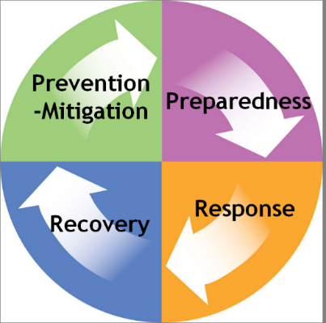
Emergency management functions are generally grouped into the four phases of mitigation, preparedness, response, and recovery. The grouping of emergency management functions is useful for classifying and conceptualizing activities. While useful for targeting efforts and resources, the phases of emergency management are not distinct—activities in each phase often overlap with other phases. For example, recovery projects often include elements of mitigation (i.e., rebuilding structures using current building codes) and response often includes recovery measures (i.e., immediate debris removal). The phases are also cyclical in nature—lessons learned from an incident are applied in preparedness efforts for future emergencies and major disasters. The following sections provide examples of the types of activities that take place in each phase.

Mitigation
Mitigation activities occur before, during, and after incidents. Post-disaster mitigation is part of the recovery process. Eliminating or reducing the impact of hazards that exist within the city/jurisdiction and are a threat to life and property are part of the mitigation efforts.
Mitigation tools include:

Detailed plans to mitigate future hazards

Land use planning

Local ordinances and statutes (zoning ordinances, building codes, etc.)

Structural measures

Tax levies or abatements

Public information and community relations

Preparedness
Preparedness activities are taken in advance of an emergency and develop operational capabilities, enact protective measures, and enhance effective responses to a disaster. These activities can include emergency/disaster planning, training and exercises, and public education. Citizen Preparedness activities are key elements in this phase and a significant factor in the success of a community in responding to an emergency. Members of the incident management enterprise and local organization develop EOPs, SOPs, and checklists detailing personnel assignments, policies, notification rosters, and resource lists. Personnel are made familiar with these EOPs, SOPs, and checklists through periodic training in the activation and execution of procedures.
OES/OEM maintains several contact lists of agencies and personnel critical to emergency operations. Those lists include; city/jurisdiction EOC responders, key contacts within cities/towns and county agencies, state agency contacts, and other organizational contacts.

Response
The response phase can be further broken down into three types of response—pre-emergency, immediate, and on-going emergency responses.
Pre-Emergency Response (or Crisis Response) if warning mechanisms exist for a particular hazard then response actions to emphasize protection of life, property, and environment can be anticipated. Typical pre-emergency and crisis response actions may include:

Alerting necessary agencies, placing critical resources on stand-by

Warning threatened populations of the emergency and apprising them of safety measures to be implemented

Evacuation of threatened populations to safe areas

Identifying the need for mutual aid

Proclamation of a Local Emergency by local authorities
Immediate Emergency Response During this phase, emphasis is placed on saving lives and property, attempting to establish and maintain control of the situation, and minimizing effects of the disaster. Immediate response is accomplished within the affected area by local government agencies and segments of the private sector. The primary activities are on-scene by first or early responders.
On-Going (or Sustained) Emergency Response In addition to continuing preservation of life and property operations, mass care, relocation, public information, situation analysis, status and, damage assessment operations may be initiated. Ongoing response usually involves many organizations and the activation of the City/Jurisdictional EOC.

Recovery
At the onset of an emergency, actions are taken to enhance the effectiveness of recovery operations. Recovery includes both short-term activities intended to return vital life-support systems to operation, and long-term activities designed to return infrastructure systems to pre-disaster conditions. The recovery phase may also include cost recovery activities. The major objectives of the recovery period include:

Reinstatement of family and community integrity

Provision of essential public services

Restoration of private and public property

Identification of residual hazards

Preliminary plans to mitigate future hazards

Recovery of costs associated with response and recovery efforts

Coordination of state and federal public and individual assistance

Organization and Assignment of Responsibilities

Organization and Assignment of Responsibilities
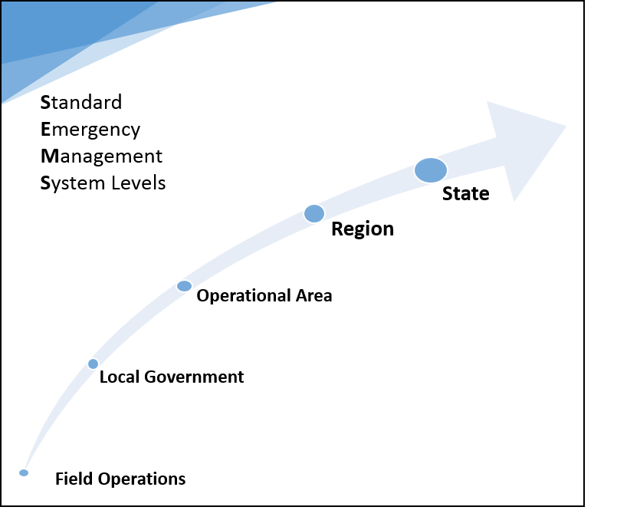
SEMS designates five organizational levels—field response level, local government level, OA level, regional level, and state level with each level being activated in a modular component network style as needed.

Field Response
The field response level is where emergency response personnel and resources, under the command of an appropriate authority, carry out tactical decisions and activations in direct response to an incident, multiple incidents, or threat. This is the incident level- where the emergency response begins. SEMS regulations require the use of ICS at this level of an incident. Field response agencies are most often represented by fire, law enforcement, EMS, and public health, although roads and airports and parks may be early responders in the field as well.

Local Government
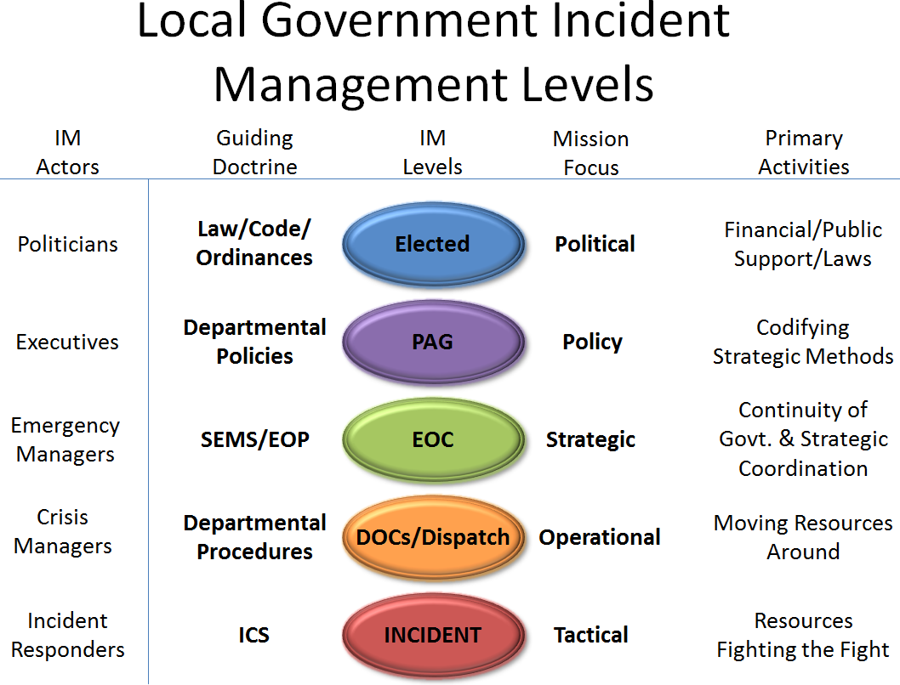
Local governments include cities/towns, counties, and special districts. Local governments manage and coordinate the overall emergency response and recovery activities between emergency agencies and operations centers within their jurisdiction (such as local EOCs and DOCs). This is the first coordination level above the field response. Local governments are required to use SEMS when their emergency operations center is activated or a local emergency is declared.

Operational Area (OA)
The “Operational Area” is conceptual in nature and incorporates the effective incident management collaboration of the various jurisdictions within the boundaries of Santa Clara County. The County of Santa Clara, as a jurisdiction and organization is charged with taking the lead coordination and arbitration role within the OA and with being the primary point of contact and for the region and state. In an OA lead entity capacity, the County manages and/or coordinates information, resources, and priorities among local governments and serves as the link between the local government level and the regional level. At this level, the governing bodies are required in SEMS to reach consensus on how resources will be allocated in a major crisis affecting multiple jurisdictions or agencies.
California Government Code, Title 2, Division 1, Chapter 7, Article 9—California Emergency Services Act— defines an operational area as:
“Each county is designated as an operational area. In a state of war emergency each operational area shall serve as a link in the system of communications and coordination between the state’s emergency operating centers and the operating centers of the political subdivisions comprising the operational area.
The governing bodies of each county and of the political subdivisions in the county may organize and structure their operational area.
An operational area may be used by the county and the political subdivisions comprising the operational area for the coordination of emergency activities and to serve as a link in the communications system during a state of emergency or a local emergency.” (Government Code § 8605)
Additionally, in accordance with California Code of Regulations, Title 19, Division 2, Chapter 1, Article 4—Standardized Emergency Management System—“The county government shall serve as the lead agency of the operational area unless another member agency of the operational area assumes that responsibility by written agreement with County government.” (19 California Code of Regulations § 2409)

Operational Area Agreement
In accordance with state statute the OA was organized in 1995 with a cooperative agreement (Santa Clara County Ordinance Code § A8-5) between the County and the 15 cities/towns located within the county geographic area. The Santa Clara County Operational Area Disaster Response and Recovery Organization Interim Agreement defines the OA and provides for sharing of critical information and emergency resources in a disaster, as well as for compliance with SEMS requirements.

Operational Area Responsibilities
The implementation of SEMS and NIMS is a cooperative effort of all departments and agencies within the county, cities/towns, and special districts that have an incident management and/or emergency response role. While every jurisdiction is charged with SEMS and NIMS compliance, County OES has the lead responsibility for SEMS and NIMS collaboration, implementation, and planning with responsibilities for:

Communicating information within the OA on SEMS and NIMS requirements and guidelines

Coordinating SEMS and NIMS training and development among county departments and agencies

Reporting NIMS compliance to Cal OES and the Department of Homeland Security

Incorporating NIMS requirements into this EOP and County of Santa Clara Ordinance Code with adoption by the County Board of Supervisors

Identification of all county departments and agencies involved in field level response

Identification of departments and agencies with a DOC

Coordinating with local jurisdictions and volunteer and private agencies on development and implementation of SEMS and NIMS

Identification of special districts that operate or provide services within the OA

Determining the emergency role of the OA special districts and making provisions for coordination during emergencies

Identification of local volunteer and private agencies that have an emergency response role

Determining the emergency role of the OA volunteer and private agencies and making provisions for coordination during emergencies

All local government staff who may work in the OA EOC, in a DOC, or at the field level will receive appropriate SEMS/NIMS/ICS training as recommended by the Department of Homeland Security. New personnel will be trained as they are hired. To validate preparedness and planning efforts, local governments will develop an exercise program that provides periodic exercises for EOC and DOC personnel under SEMS/NIMS/ICS guidelines

Operational Area Emergency Organization (your jurisdictional Emergency Organization)
Relevant Ordinances: The County of Santa Clara Code of Ordinances, Division A8, Section § A8-10 establishes The County Executive as the Director of Emergency Services and the Chief Operating Officer as Director of Emergency Services, during any temporary absence or disability of the County Executive. Board resolution additionally identifies succession of the Director of Emergency Services to include, County Counsel and Deputy County Executives by name. The Director of Emergency Services is responsible to the Board of Supervisors.

Operational Area Emergency Operations Center (OA EOC) (your jurisdictional EOC)
The Director of Emergency Services is supported by OES staff and will coordinate the county’s strategic disaster response and management out of the OA EOC.
Briefly describe EOC function: EXAMPLE: An EOC is a location from which centralized emergency management can be performed during an emergency or disaster. An EOC makes possible a coordinated response by the Director of Emergency Services, emergency management staff, and representatives from agencies and other organizations who are assigned emergency management responsibilities. An EOC provides a central location of authority and information, and allows for face to face coordination and collaboration among personnel that represent governmental incident management functions/capabilities who must make strategic emergency decisions to ensure incident support and continuity of government.
The OA EOC is the focal point for communication between the OA and the State, as well as between the OA and local jurisdictions within the county (e.g., cities/towns and special districts). Position-based SOPs and checklists are followed during an OA EOC activation. The level of staffing will vary based on the needs of the specific event or incident. Ensuring the OA EOC is ready to activate at any time is the responsibility of the Director of Emergency Services and is carried out by county OES staff.
Provide a list of activities performed at EOC: EXAMPLE: The following activities are performed in the OA EOC:

Information Sharing

Limited Resource Management

Support of field response operations

Receive and disseminate warning information

Collect intelligence from, and disseminate information to, the various OA EOC representatives, and, as appropriate, to county, cities/towns, special districts, state and federal agencies

Prepare intelligence/information summaries, situation reports, operational reports, and other reports as needed

Maintain general and specific maps, information display boards, and other data pertaining to OA emergency operations and situational awareness

Ensure Continuity of government priorities, objectives, and actions are taken

Analysis and evaluation of all data pertaining to OA emergency operations

Maintain contact and coordination with county DOCs, other local jurisdiction EOCs, and the state

Provide emergency information and instructions to the public, making official releases to the news media and the scheduling of press conferences, as necessary

Develop emergency policies and procedures in collaboration with senior policy advisory executives
Location
Address and location of your primary and alternate Emergency Operations Center (EOC). Please write a brief comment regarding the history of your EOC
Activation List your jurisdictional thresholds for EOC activation (as example see the following county and operational area triggers for activation. You may optionally retain and include the OpArea activation threshold description) Pursuant to the California Code of Regulations, Title 19, Division 2, Chapter1, Article 4—Standardized Emergency Management System—the OA EOC shall be activated and SEMS used when any of the following conditions exist:

A local government within the OA has activated its EOC and requested activation of the OA EOC to support their emergency operations

Two or more cities/towns within the OA have proclaimed a local emergency

The county and one or more cities/towns have proclaimed a local emergency

A city/town, or the county has requested a governor’s proclamation of a state of emergency

A state of emergency is proclaimed by the governor for the county or two or more cities within the OA

The OA is requesting resources from outside its boundaries, except those resources used in normal day-to-day operations which are obtained through existing mutual aid agreements

The OA has received resource requests from outside its boundaries, except those resources used in normal day-to-day operations which are obtained through existing mutual aid agreements
In all other cases, activation will be at the discretion of the Director of Emergency Services as advised by OES duty officer and emergency management staff. A resolution of the Board of Supervisors acknowledges the current designation by the Director of Emergency Services of the order of succession to that office.
Objectives The overall objective of emergency management is to ensure the effective government preparedness, mitigation, response, and recovery for situations associated with natural disasters, terrorist attacks, technological incidents, and national security emergencies. To carry out its responsibilities, the city/jurisdiction EOC organization will accomplish the following objectives during a disaster/emergency:

Support and coordinate emergency response and recovery operations

Provide an active presence of the County Executive, or designee, in setting objectives, establishing priorities, and making decisions that affect county government and the general public

Coordinate and work with appropriate federal, state and other local government agencies, as well as applicable segments of private sector entities and volunteer agencies to assess situation status, monitor resource needs, and coordinate requests for resources from outside agencies and jurisdictions

Establish priorities and resolve conflicting demands for support or scarce resources

Ensure Continuity of government priorities, objectives, and actions are taken

Prepare and disseminate information to alert, warn, and inform the public

Collect and disseminate damage and other essential data about the situation

Fulfill obligations for intelligence gathering and information flow as described in SEMS and other guidelines

Provide logistical support for the emergency response where appropriate and requested

Oversee and manage activities incurring costs and expenditures

Collect records needed for successful cost recovery
Organization The diagram below is the current EOC organizational structure. (Insert your local EOC organizational chart – example: see County EOC organizational chart below)

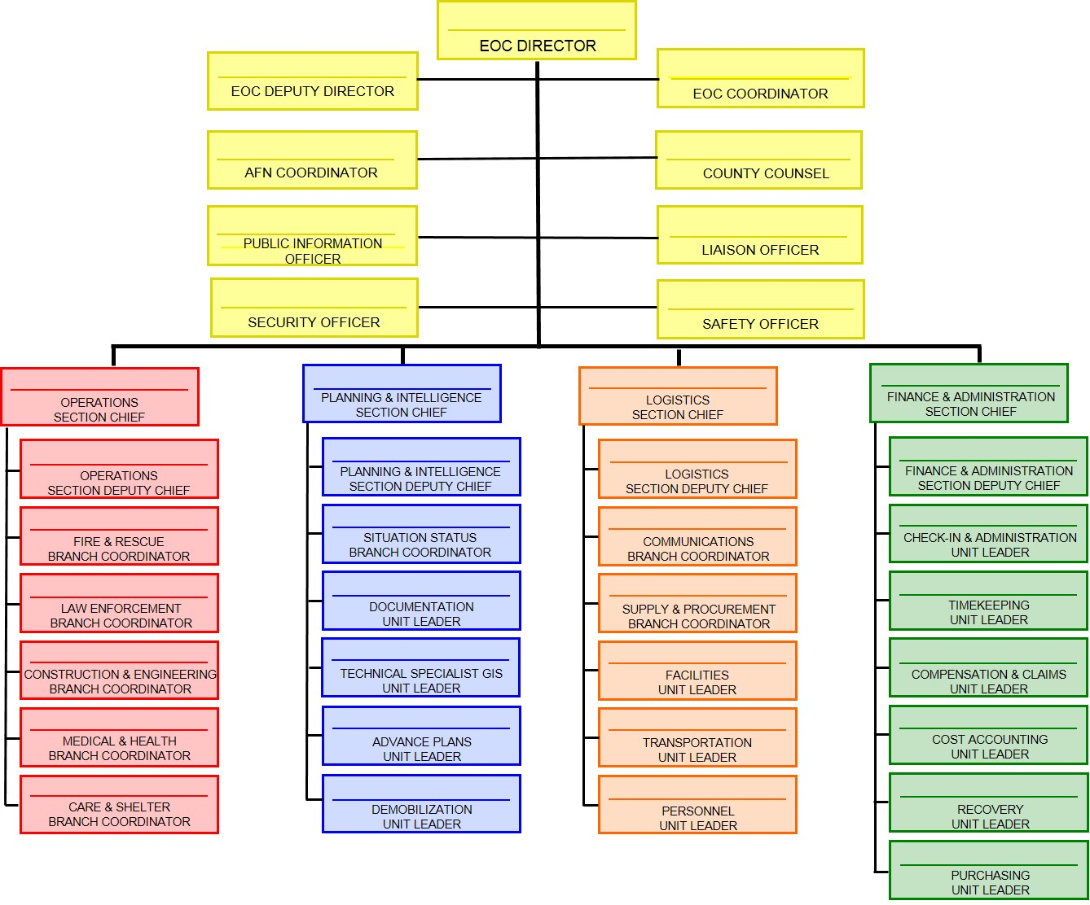
Deactivation Deactivation of the city/jurisdiction EOC occurs upon order of the EOC Director based on incident status. Deactivation may occur through a gradual decrease in staffing or all at once. OA EOC responders must follow applicable deactivation procedures as directed by the EOC Director and identified in the OA EOC position-specific checklists.

Region (your jurisdictional region)
Because of its size and geography, the state has been divided into three administrative regions each with an EOC, to include the Southern, Coastal, and Inland regions. Santa Clara County is in the Coastal Region. Additionally, the state has been divided into six mutual aid regions. Santa Clara County resides in Mutual Aid Region Two, which is based out of Alameda County. The Regional Emergency Operations Center (REOC) prioritizes requests and provides support to the OAs in their region. This is to provide for more effective application and coordination of mutual aid and other related activities.

State
The State Operations Center (SOC) level is located in Sacramento at the Cal OES headquarters. Cal OES manages state resources in response to the emergency needs of the other levels. The state also serves as the coordination and communication link between the state and the federal disaster response system.

Additional Support and Planning Organizations (Some of the groups below may overlap with your jurisdiction, please edit accordingly)
The groups, committees, and organizations identified below all participate in ensuring the county’s preparedness to respond to emergencies and disasters.

Disaster Service Workers (DSWs)
The Disaster Service Worker Volunteer Program (DSWVP) was created as the result of legislation to provide workers’ compensation benefits to registered Disaster Service Worker (DSW) volunteers who are injured while participating in authorized disaster-related activities, including pre-approved training. Disaster service, as defined for the Program, is designed to aid in the response and recovery phases in a disaster or emergency. It does not include the day-to-day emergency response activities typically associated with, for example, law enforcement, fire services or emergency medical services. The Program also provides limited immunity from liability.

In accordance with state law (California Code of Regulations (CCR) Title 2, Division 2, Chapter 2, Subchapter 3) and county ordinance all county employees are designated as disaster service workers DSW. In the event of an emergency the expectation is that county employees will secure their own homes and families and then, if possible and if they are so instructed, they will return to the county to assist in response activities. Continuity of government services is critical during disasters, and county employees will play an important role in maintaining the services necessary for the community to recover from a disaster. Additionally, volunteers may register with the county through designated Emergency Volunteer Centers (EVC) on an as-needed basis in an emergency to be designated DSWs and fill important roles in the overall response effort. Volunteer DSWs may include:

Community Emergency Response Team (CERT) members

Amateur radio operators

Other volunteers
Community Emergency Response Team (CERT) The CERT program educates people about disaster preparedness for hazards that may impact their immediate area and trains them in basic disaster response skills such as: fire safety, light search and rescue, team organization, and disaster medical operations.
Using classroom and simulation based education; CERT members can assist others in the neighborhood or workplace immediately following an event when emergency responders may not be immediately available to help.

The County Office of Emergency Services will continue to promote a consistent and standardized approach to CERT team activation, mobilization, utilization, and integration in to the Operational Area Incident Management structure.
Amateur Radio Emergency Services/Radio Amateur Civil Emergency Services (ARES/RACES) Santa Clara County has trained amateur radio operators, registered with their respective city/town and/or county ARES/RACES organization. Local ARES/RACES radio operators are a primary source of initial damage assessment in any significant incident. They respond immediately to any obvious incident with assessment of their local area and report to the county radio personnel at the OA EOC.

Emergency Operational Area Council (EOAC)
The Santa Clara County Emergency Operational Area Council (EOAC) is charged in Santa Clara County Ordinance Code § A8-24 with the purpose to enhance planning and preparedness for large-scale emergencies; to create effective partnerships in emergency planning, preparedness, training and exercise within the OA; to consolidate activities of cities and special districts to participate more efficiently in planning for future emergencies and disasters; to provide access to public-private partners to participate in emergency planning and preparedness; and to develop broad-based emergency preparedness and planning funding priorities and recommendations.

Operational Area Signatories (OAS)
The Operational Area Signatories (OAS) is an advisory body to the EOAC and is made up of emergency management representatives from the various jurisdictions and special districts within the OA. The OAS collaborates on emergency and incident management planning, logistics, and training and exercise priorities to ensure greater OA consistency and interoperability, as well as ensuring periodic information sharing and situational awareness. Additionally, OAS makes recommendations to the EOAC for Emergency Management Performance Grant (EMPG) proposals and funding.

Operational Area Advisory Group
The Operational Area Advisory Group is the mechanism by which the OAS ensures and captures whole community engagement, as recommended by FEMA, in its planning priorities, processes, and development; its training and exercise priorities, curriculums, and schedules; and its operations center (EOCs & DOCs) capability, interoperability, and functionality. Various core teams, working groups, and sub-working groups are established in topical areas to develop products; trainings and exercises; prioritize projects; and advise and report to the OAS on progress and status.

Disaster Preparedness Executive Committee
Describe Jurisdiction’s Disaster Council Roles, Responsibilities, and authorities.

Santa Clara County Emergency Managers Association
The Santa Clara County Emergency Managers Association is a professional organization of emergency management representatives. The group meets to discuss and coordinate local emergency preparedness, disaster recovery, hazard mitigation, and emergency and incident management-related issues and trends.
Special Districts and Other Organizations.
Many special districts, utilities, and private companies such as the Valley Transportation Authority (VTA), Santa Clara Valley Water District (SCVWD), and San Jose Water Company also have incident management systems for continuity of operations and to provide resources in support of an emergency response. Community Based Organizations (CBOs), Non-Governmental Organizations (NGOs), and private-sector organizations provide a range of services to address needs that are wholly or partly unmet by local, state, and federal governments during response and recovery operations.

(This page intended to be blank)

Direction, Control, and Coordination

Direction, Control, and Coordination
The emergency response is coordinated under SEMS, which provides a flexible, adaptable and expandable response organization to address all-hazards of varying magnitude and complexity. An EOC is activated to support field operations and ensure continuity of government when an incident threatens government services, requires additional resources beyond the capacity of the responding agency, or when resources exceed that which is available from within the jurisdiction as a whole. Communications between the field response, DOCs, and the EOC are established when the EOC is activated in support of field operations. Each local government’s EOC will establish communications with the OA EOC and the OA EOC will communicate with the state through the REOC.
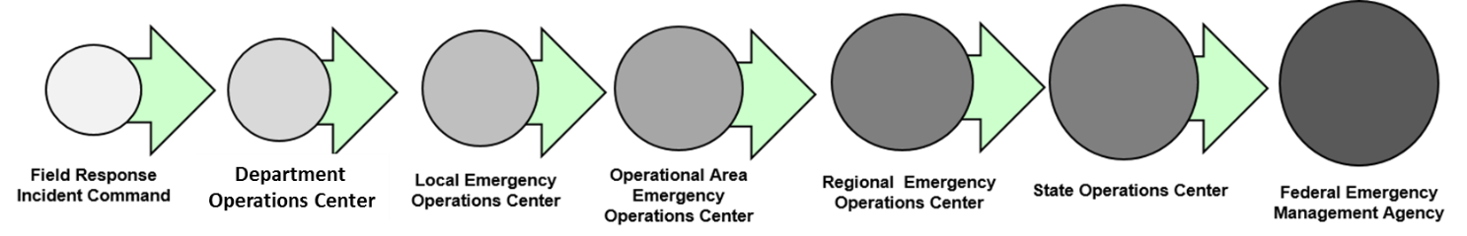

Direction and Control Interface
In a major emergency, a local jurisdiction EOC might be activated to coordinate and support the overall response. Personnel that are part of a field level emergency response will utilize ICS to manage and direct on-scene operations. Tactical management of responding resources is always under the leadership of the on-site Incident Commander (IC) at the Incident Command Post (ICP). ICs may report to the DOC dispatching resources amongst incidents, which in turn will coordinate with the local EOC. In some jurisdictions ICs may report or communicate directly to the local EOC usually to their counterpart in the operations section.
During multiple-incident situations within the county, an area command may be established to provide for the ICs at separate locations. Unified Command is an application of ICS and may be established at the field response level when more than one agency has jurisdictional responsibilities. Agencies work together through the designated members of the Unified Command to establish their designated ICs at a single ICP. Under Unified Command, entities develop a common set of objectives and strategies which provides the basis for a single Incident Action Plan.

Operational Area Coordination and Communication
As outlined in the City/Jurisdiction and OA Emergency Operations Plan, coordination and communication should be established between an activated local EOC and the OA EOC. Common communications modalities to the cities/towns from the Operational Area EOC, and to agencies not represented in that EOC include, but are not limited to, landline telephone, fax, cell phone, satellite phone, computer networks, amateur radio, and low-band EOC to EOC radio. The OA responsibilities involve coordinating with the cities/towns and other organizations to support field-level emergency response personnel, activating the OA EOC, ensuring continuity of government, and issuing orders to protect and inform the public. In accordance with ICS principles, units in the field receive tactical direction from an on-scene IC. When and where possible, the county will include jurisdictional representatives in planning for jurisdictional support.
When an incident occurs and this jurisdiction activates the EOC and requests OA EOC support; or additional cities/towns have proclaimed a local emergency, the county is required under SEMS to activate the OA EOC. The OA EOC then becomes the focal point for information sharing and dissemination and supports or arbitrates requests by cities/towns within the county.

Emergency Operations Center Notification
(Your agency) should maintain a roster of pre-identified/appointed city/jurisdiction EOC staff and will notify those personnel to report to the city/jurisdiction EOC using AlertSCC (or other appropriate system), the city’s alert and warning system. The EOC staff list includes city department representatives and agency representatives who are part of each SEMS (and NIMS compliant) EOC section—management, operations, plans and intelligence, logistics, and finance and administration.
The list will be utilized when directed by the Director of Emergency Services or designee activates the City/Jurisdiction EOC. The Director of Emergency Services or designee will determine what positions of the City/Jurisdiction EOC will initially be staffed and requested to report. The EOC responders list includes:

Employees from City/Jurisdiction departments and agencies with appropriate authority and expertise

Representatives from outside agencies including:

Special districts

Other government agencies

Volunteer organizations

Private sector organizations

Coordination With Other Levels of Government
The city/jurisdiction has identified the jurisdictions, special districts, private non-profit (PNP) organizations, and volunteer agencies within the geographical boundaries of the city/jurisdiction that may have an emergency response role during an emergency or disaster. Their emergency roles have been identified and provisions for coordination with each of them made. The city/jurisdiction will also work with the county to request up to state and federal agencies that have emergency responsibilities to ensure they are integrated into coordination of emergency operations as appropriate.

Coordination With Special Districts
Special districts are defined as local governments in SEMS and often have unique resources, capabilities, and vulnerabilities. The emergency response role of special districts is generally focused on the return to normal services. During disasters, some types of special districts will be extensively involved in the emergency response by assisting other local governments.
Coordination and communications should be established with special districts that are involved in emergency response. Relationships among special districts, cities/towns, the county, and the OA, as a whole, are complicated by overlapping boundaries and by the multiplicity of special districts. Special districts need to work with the local governments in their service areas to determine how best to establish coordination and communications in emergencies.
Typically, special district boundaries cross municipal boundaries. A special district may serve several cities/towns and county unincorporated areas. Some special districts serve more than one county. In such a situation, the special district may provide a liaison representative to the City EOC to facilitate coordination and communication with the various entities it serves. The city/jurisdiction works closely with key utilities providers and transportation agencies.

Coordination With Non-Profit and Volunteer Organizations
The city/jurisdiction recognizes the valuable assistance and resources provided by NGO partnerships and the importance of organizations that perform voluntary services in the community. As a result, the city/jurisdiction continues to cultivate relationships with PNP (Private Non-Profit) organizations and has established an extensive trained volunteer base to support emergency response operations within the city/jurisdiction. The City EOC will generally be a focal point for coordination of response activities with many PNPs and volunteer groups.
Private non-profit agencies and volunteer groups that have a key response role will have representatives at the City EOC. For example, American Red Cross personnel will be part of the staff for the City EOC Care and Shelter Branch. Collaborative Agencies Disaster Relief Effort (CADRE), the local Voluntary Organizations Active in Disaster (VOAD) organization, also staffs a City EOC position as allied agencies in order to facilitate coordination with numerous NGOs involved in emergency response and recovery efforts within communities across the City.
During an emergency, the Jurisdictional EOC may establish communication with PNP agencies and volunteer groups through an agency representative, volunteer coordinator, or other authorized personnel. Coordination, activation, and deployment of these members may be incident driven and will follow the appropriate organization response guidelines that have been established for the specific PNP organization or volunteer group.

Multi-Agency Coordination Groups
The Multi-Agency Coordination (MAC) System is one of the four pillars of SEMS, which are the ICS, MAC System, the Master Mutual Aid System, and the Operational Area Concept (as identified in the Emergency Services Act, Section 8607). In accordance with the 2013 California Statewide Multi-Agency Coordination System Guide, MAC groups are convened to address incidents or situations in which resources are considered scarce and decision-makers need to prioritize their allocation in order to best serve the communities in need.
MAC groups are established to allow subject matter experts and agency representatives to evaluate complex situations and problem sets and make actionable recommendations to the MAC group activating body (IC, DOC, EOC, etc). Activating a MAC group helps to ensure that operational tempo is not hindered for the MAC group parent organization/operations center, objectives may still be set, and progress continued to be made while still tackling difficult or complex problems or issues.
A MAC group may be convened by an EOC Director or other authority to establish priorities among multiple competing incidents, provide coordinated decision making for resource allocation among cooperating agencies, harmonize agency policies, and offer strategic guidance and direction to support incident management activities. MAC groups convened to prioritize incidents for the allocation of scarce resources should consist of administrators or executives, or their designee, who are authorized to commit agency resources and funds. A MAC group may also be referred to as a multi-agency committee, emergency management committee, interagency policy group, or as otherwise defined by the MAC System.

(This page intended to be blank)

Information Collection, Analysis, and Dissemination

Information Collection, Analysis, and Dissemination
A primary objective of the city/jurisdiction EOC is the timely gathering of accurate, accessible, and consistent information during an emergency and sharing vetted intelligence to ensure coordinated timely emergency response and continuity of government. Status boards and other technologies for tracking emergency activities will be utilized. All city/jurisdiction EOC sections must maintain and display current status information so that other sections can quickly comprehend what actions have been taken, what resources are available, and to track damage status across the city/jurisdiction. Situation reports create a common operating picture and will be used to inform the operational objectives, priorities and strategies.
To ensure effective intelligence flow, emergency response agencies at all levels must establish communications systems and protocols to organize, integrate, and coordinate intelligence among the responding agencies.
The flow of situation reports among the levels of government should occur as follows:

Field level reports disseminated to local DOCs/EOCs

The city/jurisdiction EOC provides a jurisdictional situation report to the OA EOC based on field reports; DOC reports; and EOC activities and intelligence

Information Collection and Management Tool
An Information Collection and Management Tool is used in EOC’s to accomplish the objective of timely gathering of accurate, accessible, and consistent information during an emergency.. Every emergency event is unique, as such the Information Collection and Management Tool should be tailored to fit the circumstances and particular needs demanded by individual incidents.
At a minimum, every Information Collection and Management Tool should include the following information elements:
Essential Element of Information (e.g. boundaries of the disaster area, access points to the disaster area, jurisdictional boundaries).
Specific Information Requirement in support of an Essential Element of Information (e.g. traffic control points, safe routes, special permits required to access the disaster area).
Proposed Method or Source that could be used to obtain the Specific Information Requirement (e.g. field operation reports, GIS, reconnaissance).
Responsible Element, Section, or Agency identifies the responsible party tasked with collecting the specified information (e.g. EOC Operations Section, EOC Plans Section).
Deliverable Product specifies the mechanism the Responsible Element, Section, or Agency utilizes to relay a particular Specific Information Requirement (e.g. ICS Form 209, EOC Action Plan, incident map).
Collection Suspense or Schedule defines the reporting frequency for each Specific Information Requirement (e.g. daily, hourly, status change).
Distribution Requirement identifies the position, personnel, agency, or organization receiving the most up-to-date information in accordance with the Collection Suspense or Schedule (e.g. all EOC Section Chiefs, the REOC).

(This page intended to be blank)

Crisis Communications and Public Information

Crisis Communications and Public Information
Per NIMS, public information is coordinated and integrated across jurisdictions and functional agencies; among Federal, State, local, and tribal partners; and with private-sector entities and nongovernmental organizations. In order to effectively ensure timely and accurate public information and alert and warning messages are disseminated systems, structures, plans, policies, and equipment must be developed and identified to accomplish these tasks.

Joint Information System (JIS)
The Joint Information System (JIS) provides the mechanism to organize, integrate, and coordinate information to ensure timely, accurate, accessible, and consistent messaging across multiple jurisdictions and/or disciplines with nongovernmental organizations and the private sector. It includes the plans, protocols, procedures, and structures used to provide public information.
The JIS structure is used for ensuring that:
- Public Information Officer (PIO) functions are coordinated and integrated.
- A structure and system for developing and delivering coordinated interagency messages is provided.
- Public information plans and strategies on behalf of the incident management leadership can be developed, recommended, and executed.
- Leadership is effectively advised on public affairs issues that could affect a response effort, and rumors and inaccurate information that could undermine public confidence are controlled and managed.
Federal, State, tribal, territorial, regional, or local Public Information Officers and established Joint Information Centers (JICs) are critical supporting elements of the JIS. A robust and competent jurisdictional JIS is integral to an effective and comprehensive jurisdictional incident management capability.

Joint Information Center (JIC)
The Joint Information Center (JIC) is:
- A central location that facilitates operation of the Joint Information System.
- A location where personnel with public information responsibilities perform critical emergency information functions, crisis communications, and public affairs functions.
JICs may be established at various levels of government or at incident sites, or can be components of Multiagency Coordination (MAC) Systems (e.g., MAC Groups or EOCs). A single JIC location is preferable, but the system is flexible and adaptable enough to accommodate virtual or multiple JIC locations, as required.

EOC Communication Systems
(Insert jurisdiction’s communications capabilities)
The city/jurisdiction EOC is equipped with multiple redundant communication modalities allowing the sharing of situational awareness, resource status, raw intelligence and data, and alert and warning. The communication capabilities are routinely reviewed and updated as technology advances. Current communication resources in the city/jurisdiction EOC include, but are not limited to (list/update your jurisdictions tools and capabilities from the example catalogue below):

Land-line based phones

Cell phones

Satellite phones

Fax machines

Silicon Valley Interoperability Radio Authority (SVIRA) ECOMM phone

Internet enabled computers

Emergency Alert System (EAS)

Operational Area Satellite Information System (OASIS)

Radio systems

ARES/RACES amateur radio

Public safety frequencies (i.e., law, fire, EMS)

Government frequencies (department/agency radios)

Business/Commercial frequencies (i.e., PG&E, San Jose Water, Red Cross)

Low band frequencies (EOC to EOC radios)

Public Alerting and Notifications
During an emergency, (insert city/jurisdiction name here) is responsible for the dissemination of information to the public. Public Information Officers (PIOs) disseminate emergency instructions and critical information to affected audiences—including governments, media, and the public—to provide messages that are accessible to all sectors of the community. Several county departments, as well as, PIOs from cities/towns, special districts, PNP organizations, and private companies share in the responsibility for disseminating complete, coordinated, and correct information to the public.
The city/jurisdiction has various systems in place for disseminating warnings and emergency information to the public which are describe below:

AlertSCC AlertSCC is the county’s public alert and notification system which has been made available for use to each of the 15 cities/towns within the county. AlertSCC uses the 9-1-1 database to deliver messages to the public via landline based telephones. Additionally, the public can register through a web portal to directly receive AlertSCC alerts and notifications on cell phones and via email and SMS. (insert jurisdiction name here) representatives have been trained and authorized to create and send public alerts and notifications. OES and County Communications staff are available 24/7 to assist (insert jurisdiction name here) in creating and sending public messages, as needed.
Emergency Alert System The Emergency Alert System (EAS) is a national public warning system that may be used by local authorities to deliver important emergency information to the public via local broadcast media. The county’s primary station is KCBS (740 AM) and KSJO (92.3 FM) serves as the county’s backup station. OES and County Communications have the credentials to access EAS and script emergency messages to inform the public of a threat, the steps to be taken by them, and where additional information can be obtained.
Integrated Public Alert and Warning System The Integrated Public Alert and Warning System (IPAWS) is an internet-based capability Federal, State, and local authorities can use to issue critical public alerts and notifications. County OES has been provided a federal credential and maintains it on behalf of local jurisdictions. That credential is provided to those city’s/jurisdictions/individuals who have completed the applicable County mandatory training to be accessed through the AlertSCC system. IPAWS delivers alerts simultaneously through multiple communications devices reaching as many people as possible to save lives and protect property. These communication pathways include EAS (described above) and Wireless Emergency Alerts (WEA). The WEA system is capable of delivering alerts and notifications to cell phones within a geographic area without the cell phone being registered with the local alerting system. Best practice is to have the local Public Safety Access Point (PSAP/Dispatch) be the primary point of contact for dissemination of time sensitive alert and warning messages.

Public Awareness and Education
The public’s response to any emergency is based on their understanding of the nature of the emergency, the potential hazards, the likely response of emergency services, and knowledge of what individuals and groups with or without access and functional needs, should do to increase their chances of survival and recovery. Individuals caring for the elderly, children, or pets also need an increased understanding of their specific situation as it pertains to disaster preparedness.
Your agency makes emergency preparedness information from local, State and Federal sources available to the citizens of (insert city/jurisdiction name here). Further, Your Agency will provide special emphasis on specific hazards throughout the calendar year, aiding in the disaster preparation and education of the communities within the OA.
The (insert jurisdiction name here) Office of Emergency Services utilizes the following mediums for distributing incident management and preparedness information to the public and partnering stakeholders:
The (insert jurisdiction name here) Office of Emergency Services Website:
https://www.sccgov.org/sites/oes/Pages/Office-of-Emergency-Services.aspx
The (insert jurisdiction name here) of Emergency Services Facebook Page:
https://www.facebook.com/SCCOES/
The (insert jurisdiction name here) Office of Emergency Services Twitter feed:
https://twitter.com/SCC_OES

**Please add any additional mediums for public engagement and preparedness information**

(This page intended to be blank)

Administration, Finance, and Logistics

Administration, Finance, and Logistics

Finance Considerations
To enhance the capability of the (insert jurisdiction name here) to respond to incidents by providing financial support and coordination to city/jurisdiction incident management operations and coordinating the recovery of costs as allowed by Federal and State law, the financial priorities during incident management operations are:

Preserve life, property, and the environment

Provide continuity of financial support to the City/Jurisdiction, and OA when appropriate

Cooperate with the other sections of the city/jurisdiction EOC

Document the city/jurisdiction’s costs and recovery of those costs as allowable

Maintain a positive image for the city/jurisdiction in its dealings with the public
The Finance/Administration function will operate under the following policies during a qualifying incident/event as the situation dictates:

The Standardized Emergency Management System (SEMS) and the National Incident Management System (NIMS) will be followed

All existing county and departmental fiscal operating procedures will be adhered to unless modified by insert elected body (e.g., city council/etc.) or the EOC Director

For incident/events that render the accounting systems either inaccessible or unusable for any period of time, appropriate personnel will be on an operational period, as determined by the EOC Director. This may be a period of 12 hours
The Finance/Administration function’s primary responsibility is to maintain to the greatest extent possible the financial systems necessary to keep the city/jurisdiction functioning during an incident or crisis of any size or type. These systems include but are not limited to:

Payroll

Payments

Revenue collection

Claim processing

Cost recovery documentation
The function also supervises the negotiation and administration of vendor and supply contracts and procedures in collaboration with the incident management procurement functions.
The extent and complexity of the incident or crisis will determine the extent to which the Finance/Administration function will mobilize. For some incidents/events, only part of the section may need to be engaged. In larger more complex incidents the entire function will likely engage.
The Finance/Administration function acts in a support role in all incidents/events to ensure that all required records are preserved for future use and Cal OES and FEMA filing requirements through maintenance of proper and accurate documentation of all actions taken.
To carry out its responsibilities, the Finance/Administration function will accomplish the following during a disaster/emergency:
For incidents/events where the city/jurisdiction’s computer systems and bank are accessible and usable:

Notify the other parts of the incident management organization and city/jurisdiction departments that incident management accounting procedures will be initiated and used for the event

Determine (in collaboration with technical staff) the extent to which the county's computer systems are accessible and/or usable

Determine if the city/jurisdiction's banking institutions can continue handling financial transactions

Inform the incident management organization and city/jurisdiction departments that the payroll and payments processing will be handled on a "business-as-usual" basis except that incident management accounting procedures will be used for incident/event-related costs

Disseminate information about the incident management accounting procedures to other sections and departments as necessary

Upon proclamation or declaration of a disaster by the State and/or Federal Governments, coordinate to initiate the recovery process of the city/jurisdiction's costs

Coordinate with the other sections and departments on the collection and documentation of costs pertaining to the incident/event

Coordinate with the State and Federal disaster assistance agencies for the required inspections, documentation, audits, and other necessary work in order to recover costs
For incidents/events where the county's computer systems and/or banking institutions are either inaccessible or unusable

Notify the other parts of the incident management organization and city/jurisdiction departments that incident management accounting procedures will be initiated and used for the event

Determine (in collaboration with technical staff) the extent to which the city/jurisdiction's computer systems are accessible and/or usable

Determine if the city/jurisdiction's banking institutions can continue handling financial transactions

Inform the incident management organization and city/jurisdiction departments that payroll and payments will be on hold for a short time and that processing will continue on a normal basis as of a specified date

Activate other Finance/Administration functions as necessary

Maintain, as best possible, the financial continuity of the city/jurisdiction (payroll, payments and revenue collection)

Disseminate information about the incident management accounting procedures to other sections and departments as necessary

Upon proclamation or declaration of a disaster by the State and/or Federal Governments, coordinate with those agencies to initiate the recovery process of the city/jurisdiction's costs

Coordinate with the other sections and departments on the collection and documentation of costs pertaining to the incident/event

Coordinate with the State and Federal disaster assistance agencies for the required inspections, documentation, audits, and other necessary work in order to recover costs

Mutual Aid
The foundation of California's emergency planning and response is a statewide mutual aid system which is designed to ensure adequate resources, facilities and other support is provided to jurisdictions whenever their own resources prove to be inadequate to cope with a given situation. The basis for the system is the California Disaster and Civil Defense Master Mutual Aid Agreement (MMAA).
The MMAA was developed in 1950 and has been adopted by the state, all 58 counties, and most incorporated cities in the state. The agreement creates a formal structure wherein each jurisdiction retains control of its own facilities, personnel and resources, but may also receive or render assistance to other jurisdictions within the state. State government is obligated to provide available resources to assist local jurisdictions in emergencies. It is the responsibility of the local jurisdiction to negotiate, coordinate, and prepare mutual-aid agreements.
Mutual-aid agreements exist for:

Law Enforcement

Fire Services

Emergency Medical Services

Emergency Management

Public Utilities

Building Inspectors

Coroner

Transit Operators

Mutual Aid Systems
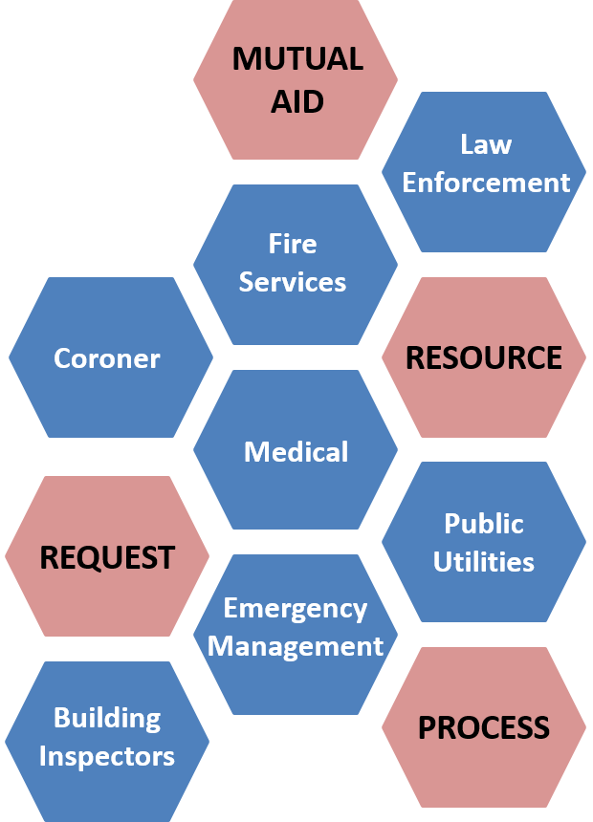
A statewide mutual-aid system, operating within the framework of the MMAA allows for the progressive mobilization of resources to and from emergency response agencies, local governments, OAs, and state regions with the intent of provide requesting agencies with adequate resources. Emergency mutual-aid response and recovery activities are generally conducted at the request and under the direction of the affected local government.
The statewide mutual-aid system includes several discipline-specific mutual aid systems, such as fire rescue and law. The adoption of SEMS/NIMS does not alter existing mutual-aid systems. These systems work through local government, OAs; regional and state levels consistent with SEMS/NIMS guidelines.
Fire agencies in Santa Clara County have signed onto a countywide mutual-aid agreement to ensure that firefighting resources and personnel will be available to combat wildland/urban interface fires. If these resources are not enough to meet the threat, fire resources from throughout the state can be requested under the MMAA. Requested mutual aid resources will be provided and utilized in accordance with the MMAA. During a proclaimed emergency, mutual aid will be coordinated at the local government, OA, or mutual aid regional level. (Insert city/jurisdiction here) has to make mutual aid requests through the OA EOC for resources not covered under the MMAA.
During and following an incident, the coordination of resources is critical when there are multiple request for similar resource or when resources are scare. It is anticipated that a Mutual Aid MAC Group will be established to coordinate mutual aid resources. The 2013 California Statewide MACS Guide provides the architecture to support coordination for incident prioritization, scarce resource allocation, communications systems integration, and information coordination.

Volunteer and Private Sector Agencies in Mutual Aid
Volunteer and private sector agencies may participate in the mutual aid system along with governmental agencies. For example, the disaster medical mutual aid system relies heavily on private sector involvement for medical/health resources. Some volunteer agencies such as the American Red Cross, Salvation Army, and others are an essential element of the statewide emergency response to meet the needs of disaster victims. Volunteer agencies mobilize volunteers and other resources through their own systems. They may identify resource needs that are not met within their own systems that would be requested through the mutual aid system. Volunteer agencies with extensive involvement in the emergency response should be represented in the city/jurisdiction EOC.
Some private sector agencies have established mutual-aid arrangements to assist other private sector agencies within their functional area. For example, electric and gas utilities have mutual aid agreements within their industry and established procedures for coordinating with a governmental EOC. In some functional areas, services are provided by a mix of special district, municipal, and private sector agencies. Mutual aid arrangements may include both governmental and private sector agencies. Liaison should be established between an activated EOC and private sector agencies involved in a response. Where there is a need for extensive coordination and information exchange, private sector agencies should be represented in an activated EOC at the appropriate SEMS level.

Special Mutual Aid Considerations For Terrorism Incidents
Terrorism incidents require response by law enforcement at many levels and require crime scene management. As such, the information flow, command structure, and mutual aid processes can be different from those in the management of other emergency situations.
A terrorist activity emergency has its own unique threat and crisis characteristics and must be dealt with in accordance to its magnitude and with an appropriate level of response. Plans and procedures have been created, exercised and revised for both the most likely and worst case scenarios.

Mutual Aid Authorities, Plans, and Guidance Documents
Mutual-aid assistance may be provided under one or more of the following authorities: (adjust for your city/jurisdiction)

California Master Mutual Aid Agreement (MMAA)

California Law Enforcement Mutual Aid Plan

Coroner Mutual Aid Plan

California Fire Service and Rescue Mutual Aid Plan

California Medical Mutual Aid Plan

Emergency Managers Mutual Aid Plan

San Francisco Bay Area Transit Operators Mutual Aid Agreement

Santa Clara County Law Enforcement Mutual Aid Protocol

California Statewide Multi-Agency Coordination System Guide

Resource management
It is state policy that resource requests for emergency response and disaster repair and restoration be entered into by the lowest level of government. When (insert city/jurisdiction here) local resources are exhausted and additional resources are required, resource requests will follow an established process for ordering, tracking, mobilizing, and demobilizing.
Maintenance of resources is important throughout all aspects of resource management. Maintenance prior to deployment ensures their availability and capability. Maintenance during the deployment phase ensures continued capabilities (e.g., ensuring adequate fuel supplies during use). Post-operational inspection and maintenance ensures future availability.

Integration of Mutual Aid Resources
In order to receive County, State, and federal resources coordination needs to be done through the OA EOC, and field level command structures. The discipline specific OA Mutual Aid Coordinators will be in charge of tracking requests for equipment, resources, and manpower under existing mutual aid protocols. The requesting agencies are responsible to report to OA EOC the number and status of resources deployed on a mission on a daily basis. Resources requested through the county EOC will be done following the prescribed county resource requesting process below:
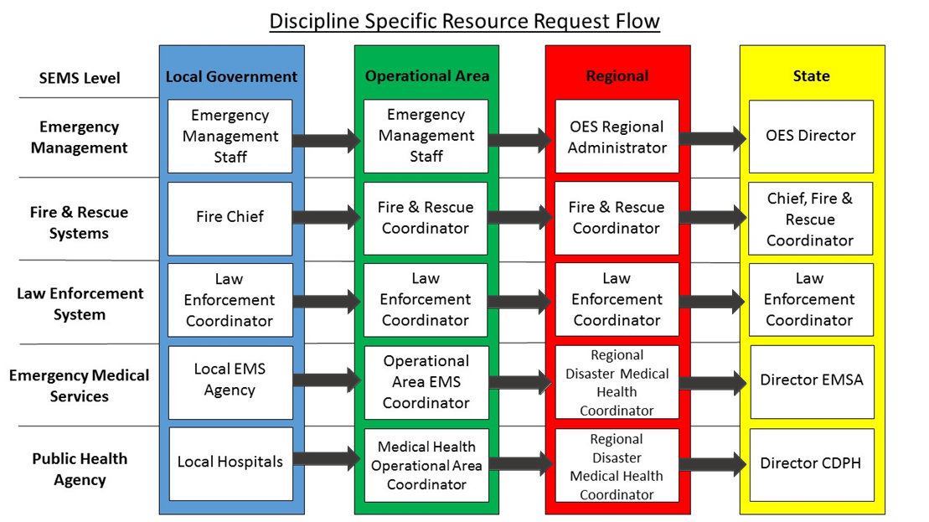
Resource typing of equipment will be handled by individual disciplines—law, fire, EMS, public works, and others—under the guidance issued by Cal OES regarding NIMS implementation.

(This page intended to be blank)

Plan Development and Maintenance

Plan Development and Maintenance

Plan Development
*Please input your jurisdictional plan development process. Much of which will overlap with the county process below.
This (Insert city/jurisdiction here) Emergency Operations Plan (EOP) was developed in collaboration with stakeholders throughout the OA in a whole community approach in compliance with Comprehensive Preparedness Guide (CPG) 101: Developing and Maintaining Emergency Operations Plans. Additionally, internal and relevant external nationwide after-actions-reports from exercises and real-world events (Stafford Act and non-Stafford Act), other county and jurisdictional EOPs, the 2016 draft NIMS Refresh, the 2007 Cal OES Emergency Operations Plan Crosswalk for Plan Review, and current incident management trends were reviewed and taken into account in an effort to address common issues and systemic operational hindrances. Annexes to the EOP are further developed in a whole community approach to augment this foundational document. Annexes are composed of major functional activities, as well as specific hazard topics that present unique or complex considerations that require more elaborate planning. A complete list of current and additional planned annexes is provided in Appendix A. The composition and planning priority of these annexes is determined by the (insert process used to determine list of local EOP annexes).

Plan Maintenance
This EOP is reviewed, updated, republished, and redistributed on a 2 year review, 5 year revision cycle in accordance with (your agency plan maintenance policy stated earlier in the plan) 2016 State Homeland Security Grant Program guidance). This EOP may be modified as a result of post-incident analyses and/or post exercise critiques. It may also be modified if responsibilities, procedures, laws, rules, or regulations pertaining to emergency or incident management and operations change. Those agencies having assigned responsibilities under this EOP are obligated to inform OES when changes are needed to reflect current process. OES will maintain records of revision to this EOP and each of the annexes as they are reviewed and updated. All changes will be noted in the Annual Review table at the beginning of this document.

Plan Concurrence
Supporting agencies and organizations include all city/jurisdiction departments who received a copy of this Plan. These city/jurisdiction departments are expected to comply with how the EOP describes their tasks.

Plan Training and Exercise
(The following statement assumes that a jurisdictional training and exercise plan/process exists based on the Homeland Security Exercise and Evaluation Program (HSEEP): A progressive, multi-year exercise plan enables city/jurisdiction to develop a series of increasingly complex exercises, with each successive exercise building upon the previous one until mastery is achieved. Regardless of exercise type, each exercise within the progressive series is linked to a set of common program priorities and designed to test associated capabilities. Further, by defining training requirements in the planning process, the city/jurisdiction can address known shortfalls prior to exercising capabilities. Below is a list of the different progressive exercise types:
Seminar – Seminars generally orient participants to, or provide an overview of, authorities, strategies, plans, policies, procedures, protocols, resources, concepts, and ideas. As a discussion-based exercise, seminars can be valuable for entities that are developing or making major changes to existing plans or procedures. Seminars can be similarly helpful when attempting to assess or gain awareness of the capabilities of interagency or inter-jurisdictional operations.
Workshop – Although similar to seminars, workshops differ in two important aspects: participant interaction is increased, and the focus is placed on achieving or building a product. Effective workshops entail the broadest attendance by relevant stakeholders. Products produced from a workshop can include new standard operating procedures (SOPs), emergency operations plans, continuity of operations plans, or mutual aid agreements. To be effective, workshops should have clearly defined objectives, products, or goals, and should focus on a specific issue.
Tabletop Exercise – A tabletop exercise (TTX) is intended to generate discussion of various issues regarding a hypothetical, simulated emergency. TTXs can be used to enhance general awareness, validate plans and procedures, rehearse concepts, and/or assess the types of systems needed to guide the prevention of, protection from, mitigation of, response to, and recovery from a defined incident. Generally, TTXs are aimed at facilitating conceptual understanding, identifying strengths and areas for improvement, and/or achieving changes in perceptions.
During a TTX, participants are encouraged to discuss issues in depth, collaboratively examining areas of concern and solving problems. The effectiveness of a TTX is derived from the energetic involvement of participants and their assessment of recommended revisions to current policies, procedures, and plans.
TTXs can range from basic to complex. In a basic TTX (such as a facilitated discussion), the scenario is presented and remains constant—it describes an emergency and brings discussion participants up to the simulated present time. Participants apply their knowledge and skills to a list of problems presented by the facilitator; problems are discussed as a group; and resolution is reached and documented for later analysis.
In a more advanced TTX, play advances as participants receive pre-scripted messages that alter the original scenario. A facilitator usually introduces problems one at a time in the form of a written message, simulated telephone call, videotape, or other means. Participants discuss the issues raised by each problem, referencing established authorities, plans, and procedures for guidance. Participant decisions are incorporated as the scenario continues to unfold.
During a TTX, all participants should be encouraged to contribute to the discussion and be reminded that they are making decisions in a no-fault environment. Effective TTX facilitation is critical to keeping participants focused on exercise objectives and associated capability targets.
Games – A game is a simulation of operations that often involves two or more teams, usually in a competitive environment, using rules, data, and procedures designed to depict an actual or hypothetical situation. Games explore the consequences of player decisions and actions. They are useful tools for validating plans and procedures or evaluating resource requirements.
During game play, decision-making may be either slow and deliberate or rapid and more stressful, depending on the exercise design and objectives. The open, decision-based format of a game can incorporate “what if” questions that expand exercise benefits. Depending on the game’s design, the consequences of player actions can be either pre-scripted or decided dynamically. Identifying critical decision-making points is a major factor in the success of evaluating a game.
Drill – A drill is a coordinated, supervised activity usually employed to validate a specific function or capability in a single agency or organization. Drills are commonly used to provide training on new equipment, validate procedures, or practice and maintain current skills. For example, drills may be appropriate for establishing a community-designated disaster receiving center or shelter. Drills can also be used to determine if plans can be executed as designed, to assess whether more training is required, or to reinforce best practices. A drill is useful as a stand-alone tool, but a series of drills can be used to prepare several organizations to collaborate in an FSE.
For every drill, clearly defined plans, procedures, and protocols need to be in place. Personnel need to be familiar with those plans and trained in the processes and procedures to be drilled.
Functional Exercise – Functional Exercises (FEs) are designed to validate and evaluate capabilities, multiple functions and/or sub-functions, or interdependent groups of functions. FEs are typically focused on exercising plans, policies, procedures, and staff members involved in management, direction, command, and control functions. In FEs, events are projected through an exercise scenario with event updates that drive activity typically at the management level. An FE is conducted in a realistic, real-time environment; however, movement of personnel and equipment is usually simulated.
FE controllers typically use a Master Scenario Events List (MSEL) to ensure participant activity remains within predefined boundaries and ensure exercise objectives are accomplished. Simulators in a Simulation Cell (SimCell) can inject scenario elements to simulate real events.
Full Scale Exercise – Full Scale Exercises (FSEs) are typically the most complex and resource-intensive type of exercise. They involve multiple agencies, organizations, and jurisdictions and validate many facets of preparedness. FSEs often include many participants operating under cooperative systems such as the ICS or Unified Command.
In an FSE, events are projected through an exercise scenario with event updates that drive activity at the operational level. FSEs are usually conducted in a real-time, stressful environment that is intended to mirror a real incident. Personnel and resources may be mobilized and deployed to the scene, where actions are performed as if a real incident had occurred. The FSE simulates reality by presenting complex and realistic problems that require critical thinking, rapid problem solving, and effective responses by trained personnel.
The level of support needed to conduct an FSE is greater than that needed for other types of exercises. The exercise site for an FSE is usually large, and site logistics require close monitoring. Safety issues, particularly regarding the use of props and special effects, must be monitored. Throughout the duration of the exercise, many activities occur simultaneously.

(This page intended to be blank)

Authorities and References

Authorities and References
Emergency response, like all governmental action, is based on legal authority. The (Insert city/jurisdiction here) Emergency Operations Plan (EOP), follows federal, state, and local regulations and guidelines. Additionally, best practices and lessons-learned have also been integrated in to this plan where possible; these were identified in the review of after-action reports from recent national large-scale disasters, incidents, and events (to include Stafford Act, non-Stafford Act, terrorist non-Stafford act, and off-shore non-Stafford act incidents and events).

Federal

Robert T. Stafford Disaster Relief and Emergency Assistance Act (PL 93-288) as amended

Homeland Security Act of 2002 (PL 107-296)

Presidential Policy Directive / PPD-8: National Preparedness

Homeland Security Presidential Directive / HSPD-5: Management of Domestic Incidents

Post-Katrina Emergency Management Reform Act of 2006 (PL 109-295)

Pets Evacuation and Transportation Standards Act of 2006 (PL 109-308)

Improving Access to Services for Persons with Limited English Proficiency (Executive Order 13166)

Individuals with Disabilities in Emergency Preparedness (Executive Order 13347)

Americans with Disabilities Act of 1990 (PL 101-336) as amended

Rehabilitation Act of 1973 (PL 93-112, Section 504) as amended

Civil Rights Act of 1964 (PL 88-352, Section VI)

Federal Civil Defense Act of 1950 (PL 920)

National Incident Management System (2008)

National Response Framework (2016)

Comprehensive Preparedness Guide (CPG) 101: Developing and Maintaining Emergency Operations Plans

State

California Emergency Services Act (Title 2, Division 1, Chapter 7 of the Government Code)

California Disaster Assistance Act (Title 19, Division 2, Chapter 6 of the California Code of Regulations)

Standardized Emergency Management System (Title 19, Division 2, Chapter 1 of the California Code of Regulations

Standardized Emergency Management System Guidelines

State of California Emergency Plan

California Disaster and Civil Defense Master Mutual Aid Agreement

California Law Enforcement Mutual Aid Plan

California Coroners’ Mutual Aid Plan

California Fire Service and Rescue Emergency Mutual Aid Plan

California Constitution (Article XI: Local Government)

Disaster Service Worker (Title 1, Division 4, Chapter 8 of the Government Code and Section 3211.92 of the Labor Code)

Local

County of Santa Clara Ordinance Code, Division A8: Civil Protection and Emergency Services

Santa Clara County Operational Area Disaster Response and Recovery Organization Interim Agreement 1995

After-Action Reports Reviewed During Plan Development (INSERT Any Additional CITY/JURISDICTIONS AARs)

Super Bowl 50 After-Action Report, County of Santa Clara, 2016

San Diego Wildfires After Action Report, May 2014

NYC Hurricane Sandy After Action Report, New York 2013

Hurricane Sandy FEMA After-Action Report, Federal Emergency Management Agency, 2013

After Action Report for the Response to the 2013 Boston Marathon Bombings, Massachusetts Emergency Management Agency

U.S. Response to the Ebola Epidemic in West Africa, Fact Sheet, 2014

Incident Specific Preparedness Review (ISPR)—Deepwater Horizon Oil Spill, U.S. Coast Guard, Department of Homeland Security, March 2011

In addition to the above AAR’s lessons learned from Operational Area practitioners deployed through the California Emergency Management Mutual Aid system to Lake County, Sonoma, Santa Barbara, informed this document

(This page intended to be blank)

Glossary

Acronyms
ADA Americans with Disabilities Act
ALERT Automated Local Evaluation in Real Time
ARES Amateur Radio Emergency Services
CADRE Collaborating Agencies Disaster Relief Effort
CAL FIRE California Department of Forestry and Fire Protection
Cal OES California Governor’s Office of Emergency Services
CBO Community-Based Organization
CERT Community Emergency Response Team
DOC Department Operations Center
DPEC Disaster Preparedness Executive Committee
DSW Disaster Service Worker
EMS Emergency Medical Services
EAS Emergency Alert System
EF Emergency Function
EMPG Emergency Management Performance Grant
EOAC Santa Clara County Emergency Operational Area Council
EOC Emergency Operations Center
EOP Emergency Operations Plan
ESF Emergency Support Function
FE Functional Exercise
FEMA Federal Emergency Management Agency
FSE Full-Scale Exercise
HSPD Homeland Security Presidential Directive
HSEEP Homeland Security Exercise and Evaluation Program
IC Incident Commander
ICP Incident Command Post
ICS Incident Command System
IPAWS Integrated Public Alert and Warning System
JIC Joint Information Center
JIS Joint Information System
MAC Multi-Agency Coordination
MACS Multi-Agency Coordination System
MMAA California Master Mutual Aid Agreement
MSEL Master Scenario Events List
NRF National Response Framework
NGO Non-Governmental Organization
NIMS National Incident Management System
NWS National Weather Service
OA Operational Area
OA EOC Operational Area Emergency Operations Center
OASIS Operational Area Satellite Information System
OES Office of Emergency Services
PG&E Pacific Gas and Electric Company
PIO Public Information Officer
PL Public Law
PNP Private Non-Profit
PPD Presidential Policy Directive
RACES Radio Amateur Civil Emergency Services
REOC Regional Emergency Operations Center
SCVWD Santa Clara Valley Water District
SEMS Standardized Emergency Management System
SimCell Simulation Cell
SMS Short Message Service
SOC State Operations Center
SOP Standard Operating Procedures
SVIRA Silicon Valley Interoperability Radio Authority
TTX Tabletop Exercise
VOAD Voluntary Organizations Active in Disasters
VTA Santa Clara Valley Transportation Authority
WEA Wireless Emergency Alert

Definitions
Accessible – A facility is accessible if it has the legally required features and/or qualities that ensure entrance, participation, and usability of places, programs, services, and activities by individuals with a wide variety of disabilities.
Affected Population – Anyone who has been displaced, injured, or suffered some loss due to a disaster.
American Red Cross (Red Cross) – The Red Cross is a humanitarian organization, led by volunteers, that provides relief to victims of disasters and helps people prevent, prepare for, and respond to emergencies. It does this through services that are consistent with its Congressional Charter and the Principles of the International Red Cross Movement.
Americans with Disabilities Act (ADA) – The Americans with Disabilities Act prohibits discrimination against people with disabilities in employment, transportation, public accommodation, communications, and governmental activities. The ADA also establishes requirements for telecommunications relay services.
Annex – An annex is an addition to a document.
Appendix – Appendices provide relevant information already referenced in the guidance. Typically, this includes forms used or other necessary information.
Catastrophe – A series of cascading human-caused/influenced events or incidents with or without a human caused genesis, the adverse effects/consequences of which are potentially, seemingly, or definitively irreversible. A catastrophe may be caused by a disaster, or may be the cause of a disaster, but it may not be either. A catastrophe may be an emergency or cause a state of emergency, or, an emergency or state of emergency may cause a catastrophe, but a catastrophe may not be any of the above.
Civil Unrest – Civil unrest involves a disruption of the typical social order; it can involve a strike or protest, and it can be non-violent or involve violence. Riots and rebellions are both forms of civil unrest.
Community-Based Organization (CBO) – Non-profit organizations that operate within a single local community and constitute a subset of the wider group of NGOs. They are frequently run by volunteers and often self-funding. Some are formally incorporated with written charters and boards of directors, while others are much smaller and more informal.
Crisis – Phenomenon, event, active threat, or trend, with or without specific location, posing seemingly inevitable harm to life, property, environment, organizational performance, reputation, or way of life reasonably or ethically necessitating deliberate urgent intervention. (A crisis may be local, national, or global)
Dam Failure – Partial or complete collapse of a dam causing downstream flooding.
Disaster – Any natural event or emergency (hurricane, tornado, storm, high water, wind-driven water, tidal wave, tsunami, earthquake, volcanic eruption, landslide, mudslide, snowstorm, drought, etc…), or regardless of cause, any fire, flood, or explosion which the President determines to be of such severity as to warrant major federal disaster assistance.
Disaster Service Worker (DSW) – The Disaster Service Worker program is a state-funded worker’s compensation program for government employees and affiliated volunteers who provide services to protect the health and safety, and preserve the lives and property, of the people of California. Government-affiliated volunteers, including members of the public who spontaneously volunteer to assist during a disaster, may be registered as DSWs under California’s Disaster Service Worker Volunteer Program.
Emergency – Incident(s) or crisis(es) (air pollution, fire, flood, storm, epidemic, riot, drought, sudden/severe energy shortage, plant or animal infestation or disease, Governor’s warning of earthquake/volcanic predictions, and earthquakes, etc…) posing threat to safety of persons, property, or the environment that exceeds an organization’s resources/capability.
Emergency Medical Services (EMS) – A service, providing out-of-hospital, acute medical care, transport to definitive care, and other medical transport to patients with illnesses and injuries, which prevent the patient from transporting themselves.
Emergency Operations – Actions taken during an emergency to protect life and property, care for the people affected, and restore essential community services.
Emergency Operations Center (EOC) – A site from which government officials coordinate, monitor, and support response activities during an emergency.
Emergency Operations Plan (EOP) – A document that describes how people and property will be protected in disaster and disaster threat situations; details who is responsible for carrying out specific actions; identifies the personnel, equipment, facilities, supplies, and other resources available for use in the disaster; and outlines how all actions will be coordinated.
Evacuation – Organized and supervised dispersal of people from dangerous or potentially dangerous areas.
Evacuee – All persons removed or moving from areas threatened or struck by a disaster.
Federal Emergency Management Agency (FEMA) – The Federal Emergency Management Agency (FEMA) is the federal agency responsible for coordinating emergency planning, preparedness, risk reduction, response, and recovery. The agency works closely with state and local governments by funding emergency programs and providing technical guidance and training. These coordinated activities at the federal, state, and local levels ensure a broad-based emergency program to insure public safety and protect property.
Flood – A general and temporary condition of inundation of normally dry land areas from overflow of inland or tidal waters, unusual or rapid accumulation or runoff of surface waters, or mudslides/mudflows caused by accumulation of water.
Hazard – Any source of danger or element of risk to people or property.
Hazardous Material – Any substance or material that when involved in an accident and released in sufficient quantities, poses a risk to people’s health, safety, and/or property. These substances and materials include explosives, radioactive materials, flammable liquids or solids, combustible liquids or solids, poisons, oxidizers, toxins, and corrosive materials.
Incident – The physical manifestation of crisis, event, or occurrence that has adversely affected life, property, or the environment requiring the response of at least one individual.
Incident Command System (ICS) – The Incident Command System (ICS) is a standardized emergency management concept designed to provide an integrated organizational structure for managing emergencies, and to enable coordinated emergency response across jurisdictional boundaries. ICS is the combination of facilities, equipment, personnel, procedures, and communications operating within a common organizational structure, designed to aid in the management of resources during emergencies. It is based on proven management tools that contribute to the strength and efficiency of the overall system.
Limited English Proficiency – Persons who do not speak English as their primary language and who have a limited ability to read, speak, write, or understand English.
Local Jurisdiction – Local jurisdiction refers to the cities, towns, school districts, and special districts that are encompassed within the geographical borders of the County of Santa Clara. In the case of unincorporated areas, local jurisdiction refers to the county itself.
Mitigation – Pre-event planning and actions that aim to lessen the occurrence or effects of potential disaster.
Mobilization – The process and procedures used by organizations; federal, state and local for activating, assembling, and transporting resources that have been requested to respond to or support an incident.
Multi-Agency Coordination (MAC) – The participation of government and other organizations involved at any level of the SEMS organization working together in a coordinated effort to facilitate decisions for overall emergency response activities, including the sharing of critical resources and the prioritization of incidents.
Multi-Jurisdiction Incident – An incident where multiple jurisdictions have a statutory responsibility. Under ICS, these incidents will be managed under Unified Command.
Mutual Aid – Is the voluntary aid and assistance by the provision of services and facilities, including but not limited to fire, police, medical and health, communication, transportation, and utilities. Mutual aid is intended to provide adequate resources, facilities, and other support to jurisdictions whenever their own resources prove to be inadequate to cope with a given situation.
Mutual Aid Agreement – Written agreement between agencies and/or jurisdictions in which they agree to assist one another upon request, by furnishing personnel and equipment.
Natural Disaster – Any hurricane, tornado, storm, flood, high water, wind-driven water, tidal wave, tsunami, earthquake, volcanic eruption, landslide, mudslide, snowstorm, drought, fire, or other catastrophe which causes, or which may cause, substantial damage or injury to civilian property or persons.
National Incident Management System (NIMS) – The National Incident Management System (NIMS) provides a comprehensive approach to emergency management for all hazards. NIMS integrates existing best practices into a consistent nationwide approach to domestic emergency management that is applicable to all jurisdictional levels (public and private) and across functional disciplines. NIMS is based on a balance of flexibility and standardization. NIMS is flexible, and allows government and private entities at all levels to work together to manage domestic emergencies, regardless of their cause, size, location, or complexity. NIMS also provides a set of standardized organizational structures.
National Response Framework – The National Response Framework (NRF) presents the guiding principles that enable all response partners to prepare for and provide a unified national response to disasters and emergencies—from the smallest incident to the largest catastrophe. The Framework establishes a comprehensive, national, all-hazards approach to domestic incident response. The Framework documents the key response principles, roles, and structures that organize national response. It describes how communities, States, the Federal Government, and private-sector and non-governmental partners apply these principles for a coordinated, effective national response. And it describes special circumstances where the Federal Government exercises a larger role, including incidents where Federal interests are involved and catastrophic incidents where a State would require significant support. It allows first responders, decision makers, and supporting entities to provide a unified national response.
Non-Governmental Organization (NGO) – An entity with an association that is based on interests of its members, individuals, or institutions, and that is not created by a government, but may work cooperatively with government. Such organizations serve a public purpose, not a private benefit. Examples of NGOs include faith-based charity organizations and the Red Cross.
Office of Emergency Services (OES) – OES is the lead agency in fulfilling the County’s responsibility under the California Emergency Services Act and also serves as the Operational Area Coordinator for the County of Santa Clara under SEMS.
Operational Area (OA) – A geographical area that encompasses all local governments within a county, including the county. The OA serves as the coordination and communications link between the local government and the state. The OA prioritizes resources and coordinates mutual aid among entities within the OA. Each OA is responsible for activating and operating an EOC.
Operational Area Emergency Operations Center (OA EOC) – The physical location at which the coordination of information and resources to support OA activities normally takes place.
Plan – A document that describes the broad, overall jurisdictional response to potential extraordinary emergencies or disasters.
Preparedness – The range of deliberate, critical tasks and activities necessary to build, sustain, and improve operational capability. Preparedness is a continuous process involving efforts at all levels of government and between government and private-sector and NGOs to identify threats, determine vulnerabilities, and identify required resources. Preparedness is operationally focused on establishing guidelines, protocols, and standards for planning, training and exercises, personnel qualification and certification, equipment certifications and publication management.
Recovery – The long-term activities beyond the initial emergency response phase of disaster operations that focus on returning all systems in the community to a normal status or to reconstitute these systems to a new condition that is less vulnerable.
Resources – Personnel and equipment available, for assignment to incidents or to EOCs.
Response – Activities that address the direct effects of an incident; immediate actions to save lives, protect property.
Shelter – Facilities providing safe, sanitary, and secure refuge before, during, and after disaster incidents. (Note: This may also include some facilities that provide immediate necessary safe haven sheltering during an incident, but are not capable of ongoing operations once other options are available.) Shelters may include general population shelters, medical needs shelters, or household pet shelters.
Special District – A unit of local government (other than a city or county, with authority or responsibility to own, operate, or maintain a project (e.g., a water district).
Standardized Emergency Management System (SEMS) – The Standardized Emergency Management System (SEMS) is used to manage emergency response in California. SMES consists of five hierarchical levels: field, local, operational area, regional, and State. SEMS incorporates the principles of the Incident Command System, the Master Mutual Aid Agreement, existing discipline-specific mutual aid agreements, the Operational Area concept, and multi-agency or interagency coordination and communication. Under SEMS, response activities are managed at the lowest possible organizational level.
State of Emergency – An eminent impending incident(s) or crisis(es) posing threat to safety of persons, property, or the environment that is/are likely to exceed resources/capability of the proclaiming political jurisdiction, or, the existence of an active incident which threatens a population and the adequacy of local resources is unknown.
Terrorism – The use of, or threatened use of criminal violence against civilians or civilian infrastructure to achieve political ends through fear and intimidation.
Threat – Communicated, demonstrated, or inferred intent and potential capability to harm life, property, environment, organizational performance, or way of life.
Volunteer Organizations Active in Disasters (VOAD) – Established disaster relief organizations, which for the most part are faith-based and national in scope, yet play a major role in disaster recovery at the local level. Services include, but are not limited to:
  - Repairing and replacing low-income housing
  - Mass feeding services
  - Home clean-up and repairs
  - Facilities for in-kind disaster relief supplies
  - Disaster child care
  - Material resources such as blankets, health kits, and clean up kits
  - Trauma, stress, grief, care for responders and affected population
  - Shelter management
  - Emergency sheltering of animals
  - Clean-up and debris removal
  - 2-1-1 information and referral

(This page intended to be blank)

Appendix A – County of Santa Clara Emergency Operations Plan Annexes

Your Jurisdiction Emergency Operations Plan Annexes
List of annexes to consider below, edit as needed for your jurisdiction (see a list of potential examples that represent Santa Clara County.
Animal and Pet Care – The Animal and Pet Care Annex to the County of Santa Clara Emergency Operations Plan identifies responsible agencies—public, private, and volunteer—that are responsible for providing animal and pet care during an emergency, to include; rescue, evacuation, shelter, or care of household pets.
Construction, Engineering, and Infrastructure* – The Construction, Engineering, and Infrastructure Annex to the County of Santa Clara Emergency Operations Plan details pre-incident and post-incident assessment process for public works and infrastructure; establish protocols for providing technical engineering; and construction management assistance (or guidance on how to obtain such technical assistance). Additionally, this annex should provide a damage assessment framework, while documenting steps to begin needed restoration of damaged infrastructure and public facilities.
Crisis Communication* – The Crisis Communication Annex to the County of Santa Clara Emergency Operations Plan provides a framework for the most efficient, accurate, and thorough dissemination of information. It outlines the conduct and coordination of public information activities and establishes a mutual understanding of responsibilities, functions, and operations with the OA using the Joint Information System as a foundational model.
Debris Management* – The Debris Management Annex to the County of Santa Clara Emergency Management Plan establishes points-of-collection for debris following a disaster, procedures for monitoring such debris for both environmental impact and reimbursement purposes, and delineate the jurisdictional & contracted roles & responsibilities for debris planning, removal, monitoring, and management activities.
Earthquake* – The Earthquake Annex to the County of Santa Clara Emergency Operations Plan provides guidance on coordination among county department and the OA, as well as technical information for local jurisdictions to draft more detailed earthquake operational plans.
Emergency Management* – The Emergency Management Annex to the County of Santa Clara Emergency Operations Plan provides specific information regarding the Emergency Operations Center (i.e., organization, training requirements, activation/notification procedures, considerations for sustained operations, etc).
Environmental, Food, and Agriculture* – The Environmental, Food, and Agriculture Annex to the County of Santa Clara Emergency Operations Plan provides guidance on how to detect, establish causation, control/containment methods, identify populations at risk, and evaluate residual impacts from a disease or pestilence on environmental, food, or agricultural systems.
Evacuation – The Evacuation Annex to the County of Santa Clara Emergency Operations Plan provides information for informed evacuation decision-making such as: road networks, demographic information, hazard threshold considerations, re-unification, etc. Additionally, this annex highlights a variety of considerations for re-habitation of previously evacuated areas.
Financial Management and Cost Recovery – The Financial Management and Cost Recovery Annex to the County of Santa Clara Emergency Operations Plan describes processes and procedures that ensure that funds are provided expeditiously and that financial operations are conducted in accordance with local, state, and federal policies, laws, and regulations. Successful financial management is essential for effective disaster response, as well as ensuring that state and/or federal disaster reimbursement funds can be obtained following in declared disaster. Additionally, this annex provides information concerning the state and federal disaster reimbursement process.
Fire, Rescue, and HAZMAT* – The Fire, Rescue, and HAZMAT Annex to the County of Santa Clara Emergency Operations Plan describes the process by which the OA’s Firefighting, Rescue, and HAZMAT Agencies collect and relay information from on-scene sources for the purpose of situational awareness and advanced planning with the Emergency Operation Center, ultimately supporting field operations. This annex does NOT supersede existing policies, mutual-aid agreements, or other specified responsibilities.
Flood – The Flood Annex to the County of Santa Clara Emergency Operations Plan provides guidance on coordination among county departments and the OA, as well as technical information for local jurisdictions to draft more detailed flood operational plans.
Landslide* – The Landslide Annex to the County of Santa Clara Emergency Operations Plan provides guidance regarding the coordination of county departments and the OA, as well as technical information for local jurisdictions to draft more detailed landslide operational plans.
Law Enforcement and Security* – The Law Enforcement and Security Annex to the County of Santa Clara Emergency Operations Plan describes the process by which the county Law Enforcement agencies, with the OA support, will collect and relay incident information from on-scene sources for the purpose of situational awareness and advanced planning within Emergency Operations Center, ultimately supporting field operations. This annex does not supersede existing policies, mutual-aid agreements, or other specified responsibilities.
Logistics and Resource Management* – The Logistics and Resource Management Annex to the County of Santa Clara Emergency Operations Plan provides a framework for the integration of internal and external) logistics partners (agencies in and out of the emergency operations structure) through collaborative planning, sourcing, acquisition, and utilization of resources with the purpose of re-establishing self-sufficiency as rapidly as possible. Additionally, this annex establishes a platform for collecting and sharing information pertaining to key equipment needed during common hazard types.
Mass Care and Shelter – The Mass Care and Shelter Annex to the County of Santa Clara Emergency Operations Plan defines the OA’s organization, operational concepts, and responsibilities to provide care and shelter during a disaster.
Mass Fatality* – The Mass Fatality Annex to the County of Santa Clara Emergency Operations Plan provides guidance regarding the coordination of county departments and the OA, as well as technical information for local jurisdictions to draft more detailed mass fatality operational plans.
Mutual-Aid – The Mutual-Aid Annex to the County of Santa Clara Emergency Operations Plan describes the established mutual-aid processes throughout local and state response organizations. This annex does NOT supersede any established mutual-aid agreements, but rather for clarification and reference in the event mutual-aid is needed.
Public Health and Medical Emergency* – The Public Health and Medical Emergency Annex to the County of Santa Clara Emergency Operations Plan addresses public health and medical emergencies through all emergency phases. Additionally, in an effort to more comprehensively plan for public health and medical emergencies throughout all emergency phases, the topics of pandemic and behavioral health are specifically addressed.
Public/Private Partnership* – The Public/Private Partnership Annex to the County of Santa Clara Emergency Operations Plan annex addresses how to integrate the private sector into emergency planning, response, and recovery activities by identifying key resources, infrastructure, and business components needed for continuity of operations. Additionally, this annex provides items to consider for leveraging private sector resources in the event of a disaster.
Recovery* – The Recovery Framework Annex to the County of Santa Clara Emergency Operations Plan. Recovery is the process of re-establishing a state of normalcy in affected communities. This process may best be described as a sequence of interdependent and often concurrent activities that progressively advance a community toward a successful recovery. The Santa Clara County Disaster Recovery Framework (SCCDRF) describes the concepts and principles that promote rapid and effective recovery.
It identifies scalable, flexible, and adaptable coordinating structures to align key roles and responsibilities of County agencies assigning them to Recovery Support Functions (RSFs). Additionally the Framework captures resources, capabilities, and best practices for recovering from a disaster. It recognizes significant challenges confront all recovery efforts, from a relatively localized incident to a large-scale disaster that demands substantial resources.
Severe Weather* – The Severe Weather Annex to the County of Santa Clara Emergency Operations Plan provides guidance regarding the coordination of county departments and OA, as well as technical information for local jurisdictions to draft more detailed severe weather operational plans.
Special Event* – The Special Event Annex to the County of Santa Clara Emergency Operations Plan provides guidance regarding the coordination of county departments and the OA, as well as technical information for local jurisdictions to draft more detailed special event operational plans.
Terrorism, Coordinated Attack, and Civil Unrest* – The Terrorism, Coordinated Attack, and Civil Unrest Annex to the County of Santa Clara Emergency Operations Plan provides guidance regarding the coordination of county departments and the OA, as well as technical information for local jurisdictions to draft more detailed terrorism, coordinated attack, and civil unrest operational plans.
Transportation* – The Transportation Annex to the County of Santa Clara Emergency Operations Plan establishes a framework for monitoring and reporting the status of and damage to the transportation system and related infrastructure as a result of a disaster. The annex also identifies (or helps facilitate the identification) of temporary alternative transportation solutions that can be implemented when systems or related infrastructure are damaged, unavailable, or overwhelmed.
Utilities* – The Utilities Annex to the County of Santa Clara Emergency Operations Plan provides guidance on local assistance and resources to enable the restoration of utilities as soon as possible following a large-scale disaster. The annex identifies potential system shortfalls, describes how the county, with the OA support, can assist utility providers with emergency response assistance, and describes the coordination efforts between the private and public sectors in their response efforts to ensure timely restoration of utility systems.
Volunteer and Donation Management* – The Volunteer and Donation Management Annex to the County of Santa Clara Emergency Operations Plan details volunteer and donations management related to outreach and education programs, guidance on volunteer integration, procedures to activate a Volunteer/Donations Coordination Team, call centers, relevant points of contact, safety and security considerations, and a demobilization process.
Wildfire* – The Wildfire Annex to the County of Santa Clara Emergency Operations Plan provides guidance regarding the coordination of county departments and the OA, as well as technical information for local jurisdictions to draft more detailed wildfire operational plans.

*Annex has yet to be written.

(This page intended to be blank)

Appendix B – Local / State / Federal Crosswalk
*Add any applicable jurisdictional EOC functions/positions below.

Federal / State / Local Crosswalk
The table below provides a crosswalk that approximates equivalent terms used by the Santa Clara County Operational Area, the State of California, and the U.S. Federal Government.
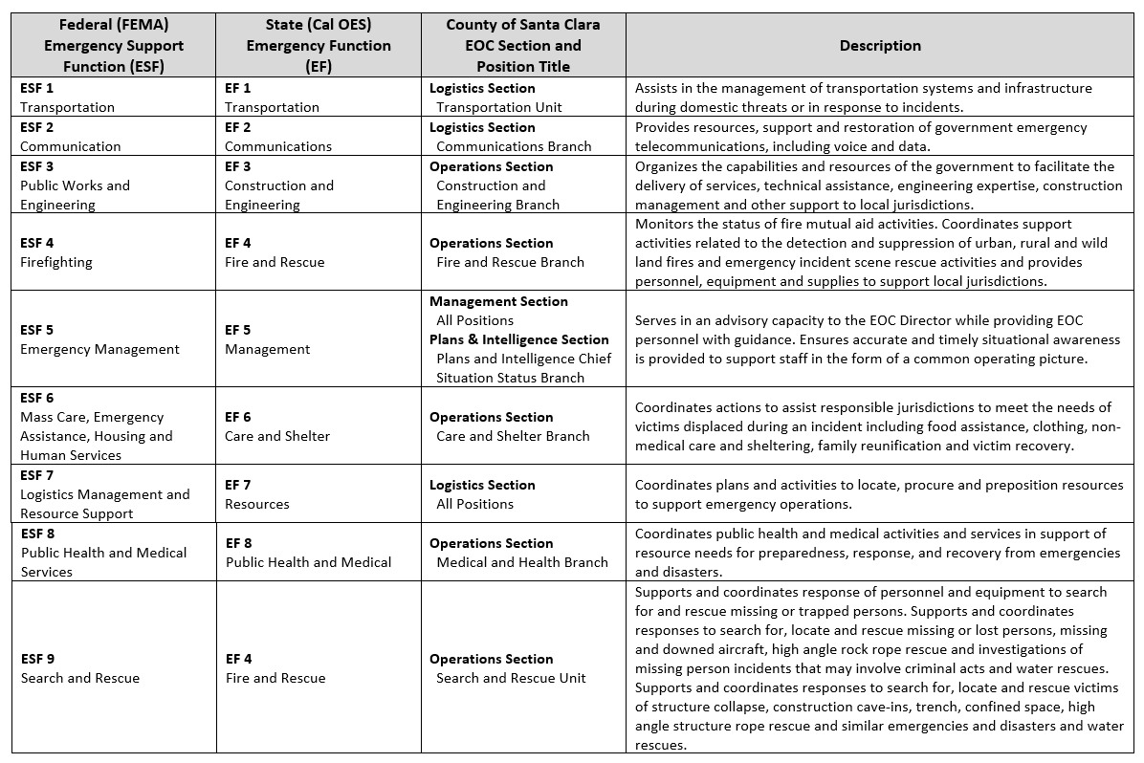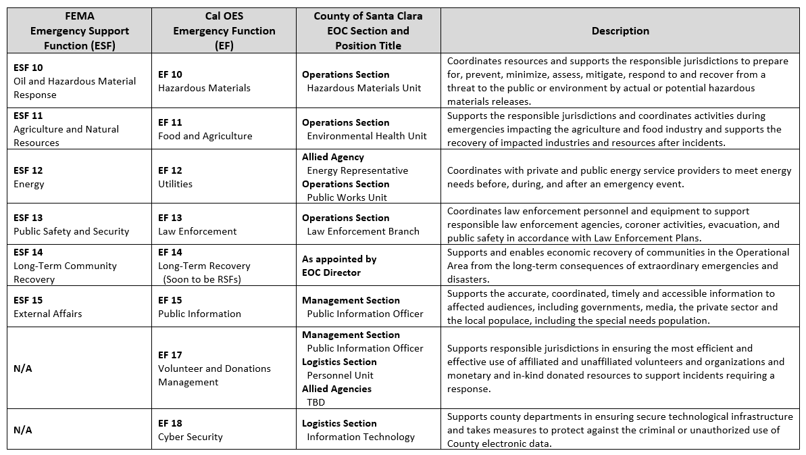

APPENDIX C – EMERGENCY ANNEX PLANNING PROCESS GUIDE

[PAGE INTENTIONALLY LEFT BLANK]

Purpose Statement

The purpose of the EOP Annex Planning Process Guide is to systematize a more collaborative Operational Area approach in alignment with FEMA’s Comprehensive Planning Guidance (CPG) 101. The model improves the planning process by providing an inclusive platform for discussion of planning priorities, dividing and assigning labor and incorporating a review process. These characteristics will yield wider stakeholder participation, increase consistency and expand the understanding of planning products.
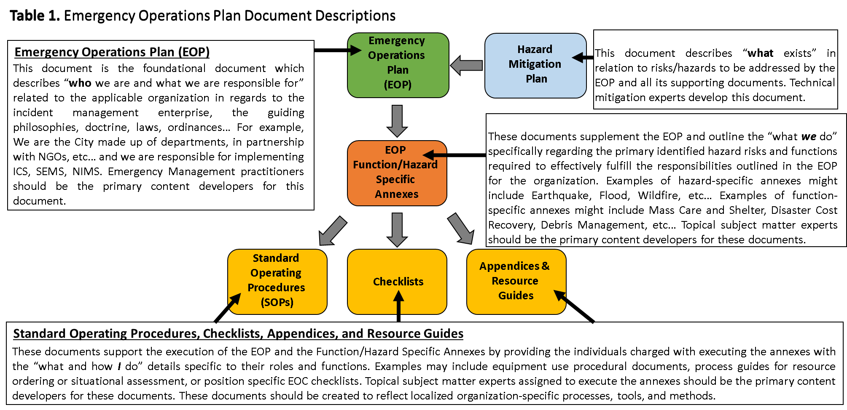

Santa Clara County Emergency Operations Plan Document Types and Descriptions

Santa Clara County Operational Area Emergency Planning Organization

Operational Area Planning Advisory Group

Purpose. The Operational Area (OA) Planning Advisory Group (PAG) sets emergency/contingency planning priorities for the entire Operational Area.

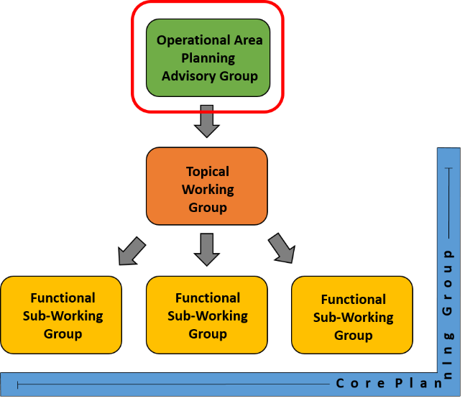
Membership Criteria. The OA PAG is open to any interested community stakeholder. At a minimum, membership in the OA PAG should include:

      - 1. Representatives from local jurisdictions.

      - 2. Key County Departments – Fleets and Facilities, Roads and Airport, Chief Executive Office, Sheriff, etc.

      - 3. Local Emergency Managers.

4. Representatives from Allied Agencies (i.e., Red Cross, Collaborating Agencies' Disaster Relief Effort, Santa Clara Valley Transportation Authority, etc.)

County of Santa Clara Office of Emergency Services Responsibilities. The OA PAG is a resource directly under the control of Santa Clara County OES. The meeting schedule, agenda, composition, stakeholder participation, and format are completely subject to Santa Clara County OES prerogative.

Meeting Frequency. The OA PAG should meet semi-annually, but the frequency is subject to change based the needs of the Operational Area.

Meeting Schedule. The first OA PAG was held on 24 November 2015; therefore, the Advisory Group should meet in the months of May and November.

Typical Activities. Conduct workshops to discern planning priorities for the OA. Present information concerning relevant hazards and capabilities. Identify and promote best practices within the OA. Provide guidance and accountability of the Operational Area Topical Working Groups and Functional Sub-Working Groups.

Suggested Topics of Discussion. Lessons learned from previous planning successes, current planning projects, and planning endeavors scheduled to begin in the near future. Additionally, this is an excellent platform for subject matter experts to discuss hazard types pertinent to the Operational Area. This is also an excellent platform for local emergency management professionals to present on their local emergency management activities to help identify and share best practices in the Operational Area.

Operational Area Topical Working Group(s)

Purpose. Operational Area Topical Working Groups endorse plan framework, identify subject matter experts, establish divisions of labor, develop work schedules, and other preparatory materials for a specific topical plan assigned by the Operational Area Planning Advisory Group.

Lead Agency. Leadership of each Topical Working Group should be established by the OA PAG in coordination with the Santa Clara County Office of Emergency Services. Leadership of a specific Topical Working Group should fall to the jurisdictional department that has primary responsibility for the plan under draft (i.e., Mass Care & Shelter - Social Services Agency). The lead agency is responsible for facilitating and coordinating all planning efforts with support from Santa Clara County OES.
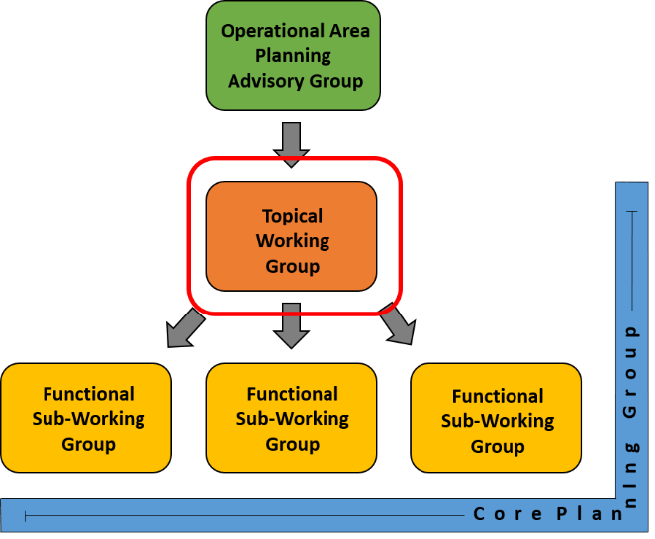
Support Agency(ies). Support Agencies are identified by the Lead Agency for the purpose of sourcing valuable information needed in crafting effective emergency annexes. Representatives should be briefed on expectations and communicate any limitations/constraints to the Topical Working Group Lead Agency to allow for potential alternate planning actions.

Suggested Membership Criteria. Membership of each Topical Working Group should include relevant jurisdictional departments, subject matter experts, and representatives from local jurisdictions. The membership level of a Topical Working Group should be commensurate with the scope of work under consideration. It should be noted that very large membership groups (more than 30 – 40 individuals) may NOT be conducive to planning at this level.

Suggested Membership Level. 20 – 35 individuals.

Meeting Frequency. Topical Working Groups should meet as needed, but at a minimum should include an initial meeting, a mid-term progress meeting, and a final meeting. Meetings can be held electronically, virtually or by phone.

Typical Activities. In order to meet the expectations detailed above, or any additional expectations established by the OA PAG, each Topical Working Group should develop the following:

- Define the current situation regarding the hazard, topic, or function under consideration – including a proposed timeline.

- Participate in and contribute to an Initial Planning Meeting, a Mid-Term Planning Meeting, and a Final Planning Meeting that includes a broad, holistic audience.

a. The Initial Planning Meeting should establish the problem to be addressed via the Emergency Planning Process, solicit opinions from Operational Area stakeholders, and develop a course of action to resolve the problem previously stated.

b. The Mid-Term Planning Meeting is intended to inform Operational Area planning partners on the progress of planning efforts in order to maintain consensus throughout the planning area and address any unresolved issues that may delay the planning process.

c. The Final Planning Meeting is intended to inform and socialize the resultant planning product among Operational Area stakeholders.

- Enlist community stakeholders and subject matter experts in the planning effort.

- Define a plan framework with specific objectives, goals, and a refined timeline.

- Divide the planning team into smaller, more manageable teams (Sub-Working Groups) and assign them to develop an area within the plan.

- In consultation with the Core Planning Group, identify Functional Sub-Working Group leaders and product deadlines/milestones.
- Each Topical Working Group will need to identify a Recorder that is tasked to complete a Meeting Minutes document, Action Item document, and a Topical Working Group Meeting Worksheet for the purpose of informing the larger planning team of progress.

County of Santa Clara Office of Emergency Services Responsibilities. The success of each Topical Working Group depends on close collaboration between Santa Clara County OES and the designated Lead Agency. While the designated Lead Agency is directly responsible for facilitating and coordinating all planning efforts under the purview of a specific Topical Working Group, Santa Clara County OES possesses the subject matter expertise, programmatic knowledge, and experience with the OA emergency planning process. Therefore, the Lead Agency’s focus should be narrow, concentrating on the function, hazard, or topic currently under consideration, while Santa Clara County OES’s focus should be broad, concentrating on plan consistency, interdependency, and standardization throughout the Operational Area’s entire emergency planning process.

Operational Area Functional Sub-Working Group(s)

Purpose. Functional Sub-Working Groups develop plan content, identify missing subject matter experts, and assign work to Functional Sub-Working Group Members to address a specific function or section of the plan assigned by the Topical Working Group with assistance from the Core Planning Group.
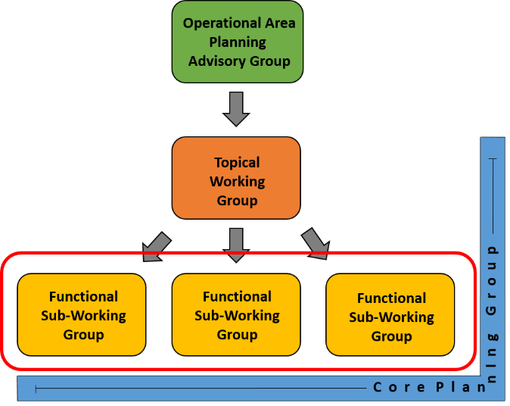
Functional Sub-Working Group Leader. Leadership of each Functional Sub-Working Group should be established by the Core Planning Group with input from the Topical Working Group and the Santa Clara County Office of Emergency Services. A member of the Core Planning Group should lead each Sub-Working Group. However, a Sub-Working Group member with highly specialized knowledge AND a commitment to the planning process can be a Sub-Working Group Leader under the guidance of the Core Planning Group, Santa Clara County OES, and the Lead Agency.

Support Agency(ies). Support Agencies are identified by Santa Clara County OES, the Lead Agency, and the Functional Sub-Working Group Leader for the purpose of sourcing valuable information needed in crafting effective emergency plan content. Support Agencies are expected to participate in all planning efforts to the greatest extent possible with the understanding that such participation may be constrained by limited resources (i.e., time, funding, and workforce). Such limitations should be communicated to the Lead Agency, Santa Clara County OES, and the Functional Sub-Working Group Leader to allow for alternate planning actions and documentation.
Suggested Membership Criteria. Membership composition of each Functional Sub-Working Group should include relevant County Departments, subject matter experts, representatives from Allied Agencies, members of the Core Planning Group, and a representatives from local jurisdictions – especially jurisdictions threatened by the hazard under consideration. The membership level of a Functional Sub-Working Group should be commiserate with the scope of work under consideration. It should be noted that small groups are MOST conducive to planning at this level.

Suggested Membership Level. 4 – 8 individuals.

Meeting Frequency. Frequency is dependent upon the proposed timeline and scope of work. Enough time should be scheduled in between each Functional Sub-Working Group to provide members an opportunity to complete any work assignments. Ultimately, the meeting frequency should be defined in coordination with the Core Planning Group and the Functional Sub-Working Group, with the goal of balancing planning needs and the demands of each member’s daily occupation.

Typical Activities. Each Functional Sub-Working Group should develop the following products and/or processes:

- Definition the current situation regarding the hazard, topic, or function under consideration, including a proposed planning timeline.

- Enlist community stakeholders and subject matter experts that are not currently included in the planning effort.

- Identify product deadlines, milestones, or shortfalls.

- Discuss and craft plan content.

- Identify a Recorder that is tasked to complete a Meeting Minutes document, Action Item document, and a Sub-Working Group Meeting Worksheet for the purpose for informing the larger planning team of progress.

- Contribute to and participate in any Topical Working Group Planning Meetings, as needed and able.

County of Santa Clara Office of Emergency Services Responsibilities. The success of each Functional Sub-Working Group depends on close collaboration between Santa Clara County OES, the identified Lead Agency, members of the Core Planning Group, and members of each Functional Sub-Working Group. As the Emergency Planning Process experts, Santa Clara County OES staff are essential to success at every level of the Operational Area emergency planning process.

Core Planning Group

Purpose. The Core Planning Group is ultimately responsible for all production activities including: proposing plan scope and framework, performing research and information validation, initiating group recruitment and continuing the management of needed planning partners, as well as drafting and editing of the planning document.
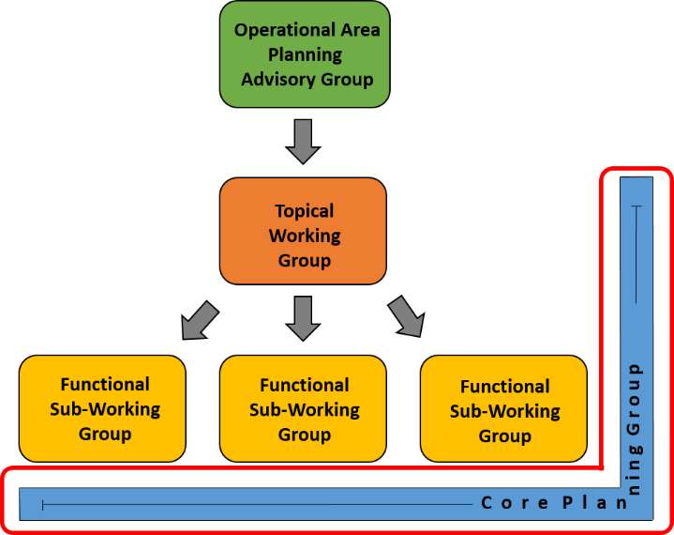
Lead Agency and OES. Leadership of the Core Planning Group is different from the other OA emergency planning entities. The Core Planning Group is more collaborative in nature. Rather than relying on a single agency to provide leadership, the Core Planning Group should strive to balance the needs of all assigned organizations through collaborative teamwork. The Core Planning Group should look to the Lead Agency for appropriate task assignments, division of labor, and guidance on relevant subject matter, while OES should provide guidance as it relates to the Emergency Management Planning Process and continuity of effort between the various OA Emergency Plans. Above all, Core Planning Group members must remain flexible, while being conscious of the needs of all agencies involved in the planning process.

Suggested Membership Criteria. Membership composition of the Core Planning Group should include representatives from the Lead Agency, OES, and any other agency deemed essential. The membership level of the Core Planning Group should be commensurate with the scope of work under consideration. It should be noted that, given the high level of coordination required for planning at this level, the Core Planning Group should remain relatively small.

Suggested Membership Level. 4 – 8 individuals.

Meeting Frequency. The Core Planning Group should meet as frequently as needed. Frequency is dependent upon the proposed timeline and scope of work. Enough time should be scheduled in between each Core Planning Group meeting to provide members an opportunity to complete any work assignments. Ultimately, the meeting frequency should be defined by the Core Planning Group members with the goal of balancing the Group’s planning needs with the demands of each member’s daily occupation.

